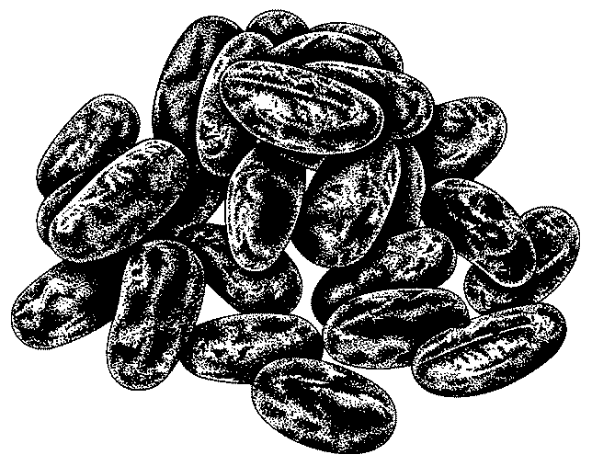

Southwest Salad

Women Infants and Children ingredients: beans…

Utensils needed: |  |  | Ingredients needed:
measuring cups  measuring spoons  serving bowl  paring knife  frying pan |  |  | 3 (15 oz.) can  2 c.  2-3  ½ c.  1 med.  1 t.  ½ c.  ½ c.  2-3 t.  ½ c.  ½ c.  1 t. | Black beans  Corn  Garlic cloves, minced  Red onion  Red pepper, minced  Salt  Olive oil  Lime juice (3-4 fresh limes)  Cumin seeds  Cilantro, minced  Parsley, minced  Red pepper, crushed  Fresh ground black pepper
Step 1  Step 2  Step 3  Step 4  Step 5 | In a large bowl, combine beans, corn, garlic, onion, pepper, salt, oil, and lime juice.  Roast cumin seeds for several minutes in a frying pan.  Add toasted seeds cilantro, parsley, and red and black pepper.  Mix well.  Serve as a salad or in a tortilla.
Talk to your infant/toddler |  |  | Explore with your Toddler
DESCRIBE THINGS |  |  | SEE
This salad is very colorful: black, yellow, red, |  |  | Look at the black beans and yellow corn.
and green. |  |  | HEAR
GIVE DIRECTIONS |  |  | Listen to the can opener while we open the beans.
Pour the lime juice over the beans. |  |  | TOUCH
ASK QUESTIONS |  |  | Feel the smooth skin of the limes.
Do you like the beans with chips? |  |  | TASTE
 |  |  | Taste the cilantro.
 |  |  | SMELL
 |  |  | Smell the cumin seeds as they are heated up.

