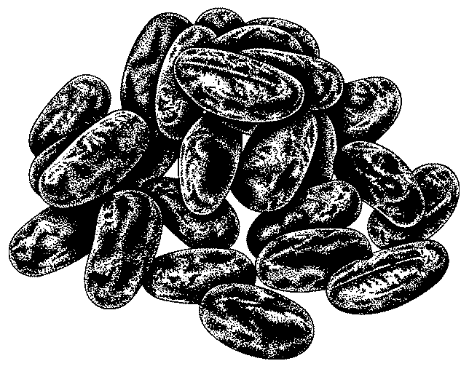

Bean Quesadillas

Women Infants and Children ingredients: beans…

Utensils needed:  measuring cups |  |  | Ingredients needed:
measuring spoons  paring knife  saucepan |  |  | 1 (15 oz.)can  1 c.  1 c.  1-2  ½ t.  ½ t.  8  3 t. | Black beans  Sweet red pepper, chopped  Monterey Jack or other cheese  Garlic cloves, finely chopped  Basil, dried  Oregano, dried  Flour tortillas, large  Oil, divided
Step 1  Step 2  Step 3  Step 4  Step 5  Step 6 | Put undrained beans in a medium saucepan over medium heat. While beans are heating, mash them lightly.  Divide the bean mixture among the tortillas.  Spread mixture 1 inch from the edges. Fold each tortilla in half.  Place the quesadillas in a non-stick pan. Cook for 2-3 minutes, or until the bottoms are golden.  Flip the quesadillas and gently press on them with a spatula to help the cheese melt. Cook for another 3-4 minutes.  Cut into wedges and serve.
Talk to your infant/toddler |  |  | Explore with your Toddler
DESCRIBE THINGS |  |  | SEE
One cheese is white and the other is orange. |  |  | Look at the beans when I smash them.
 |  |  | HEAR
GIVE DIRECTIONS |  |  | Listen to the can opener when I open the beans.
Give me one tortilla. |  |  | TOUCH
 |  |  | Feel the papery covering on the garlic.
ASK QUESTIONS |  |  | TASTE
Which cheese do you like? |  |  | Taste the two different cheeses.
 |  |  | SMELL
 |  |  | Smell the spicy garlic when it is crushed.

