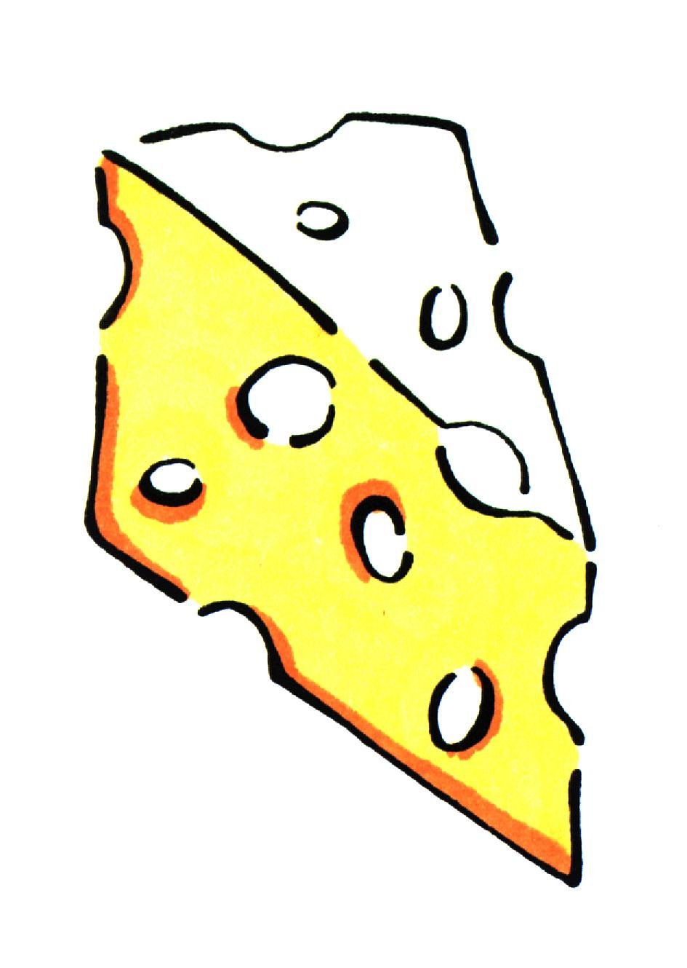

Cheesy Mini Corn Muffins

Women Infants and Children ingredients: egg, cheese

Utensils needed: |  |  | Ingredients needed:
measuring cups  measuring spoons  2 mixing bowls  muffin pan |  |  | ¼ c.  ¼ c.  1  6 T.  1 (8.5 oz.) can  ½ c.  ½ c.  1 c.  1 T.  ½ t. | Yogurt, plain, nonfat  Vegetable oil  Egg  Sugar  Cream-style corn  Cheddar cheese, shredded  Flour  Cornmeal  Baking powder  Salt
Step 1  Step 2  Step 3  Step 4  Step 5 | Preheat oven to 325º. Grease muffin cups or line with liners.  In a large bowl, mix yogurt and oil.  Add eggs, sugar and mix. Add corn, cheese, flour, cornmeal, baking powder and salt.  Mix until all ingredients are moistened.  Fill each cup with about 1 tablespoon of mixture. Bake for 13 to 15 minutes at 325º or until toothpick comes out clean. Remove from pan.
Talk to your infant/toddler |  |  | Explore with your Toddler
DESCRIBE THINGS |  |  | SEE
The corn and cheese are yellow. |  |  | Look at the pieces of corn in your muffin.
 |  |  | HEAR
GIVE DIRECTIONS |  |  | Listen to the timer go off.
Stir all the ingredients in the bowl. |  |  | TOUCH
 |  |  | Feel the cold corn.
ASK QUESTIONS |  |  | TASTE
Are all the ingredients mixed in? |  |  | Taste the cheese.

SMELL
Smell the yogurt. It smells good!

