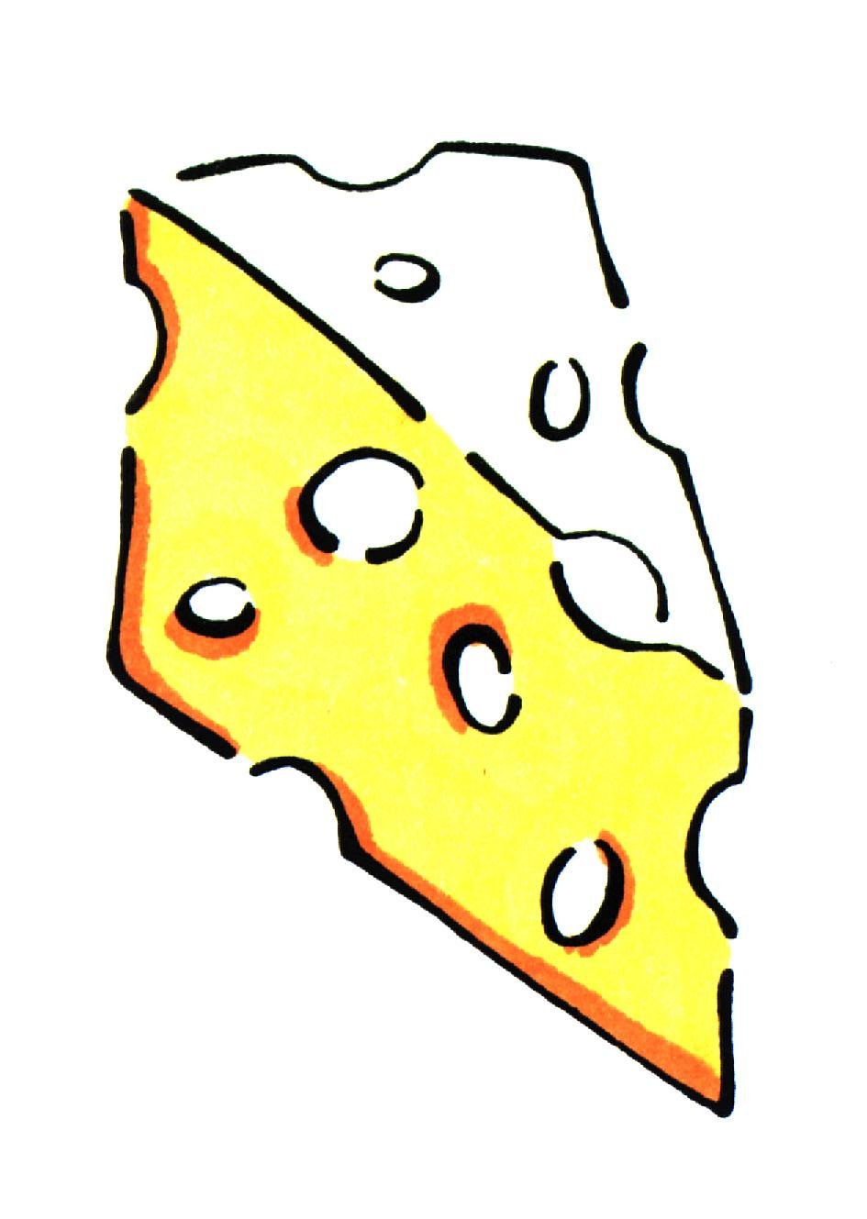

Cheesy Spinach Squares

Women Infants and Children ingredients: egg, cheese

Utensils needed: |  |  | Ingredients needed:
measuring cups  measuring spoons  2 mixing bowls  baking dish |  |  | 4 T.  1/3 c.  3  1 c.  1 c.  1 t.  1 t.  ¾ t.  2 (10 oz.) pkgs.  1 lb.  1/8 c.  1/8 c. | Butter  Green onion, chopped  Eggs  Flour  Milk  Salt  Baking powder  Dill weed  Spinach, frozen thawed  Monterey Jack cheese, grated  Pimentos, chopped finely  Egg yolk, hard cooked, crumble
Step 1  Step 2  Step 3  Step 4  Step 5 | In a frying pan, melt butter and sauté green onions until limp. Scrape butter and onions into  9 X 13 baking dish.  In a large bowl, beat eggs, then add flour, milk, salt, baking powder, and dill weed.  Let spinach drain in a sieve. Combine spinach with cheese, mix well. Add to egg mixture.  Pour mixture into baking dish and bake 350º for 35 minutes.  Garnish with pimento and crumbled egg yolk.
Talk to your infant/toddler |  |  | Explore with your Toddler
DESCRIBE THINGS |  |  | SEE
The green spinach and red pimiento look pretty |  |  | Look at the spinach dripping with water.
 |  |  | HEAR
GIVE DIRECTIONS |  |  | Listen to the butter and onions cooking.
Help me put the pimiento on each square. |  |  | TOUCH
 |  |  | Feel the soft egg yolks.
ASK QUESTIONS |  |  | TASTE
Do you like spinach and cheese together? |  |  | Taste the pimiento- it’s delicious!
SMELL
Smell the spinach squares cooking.

