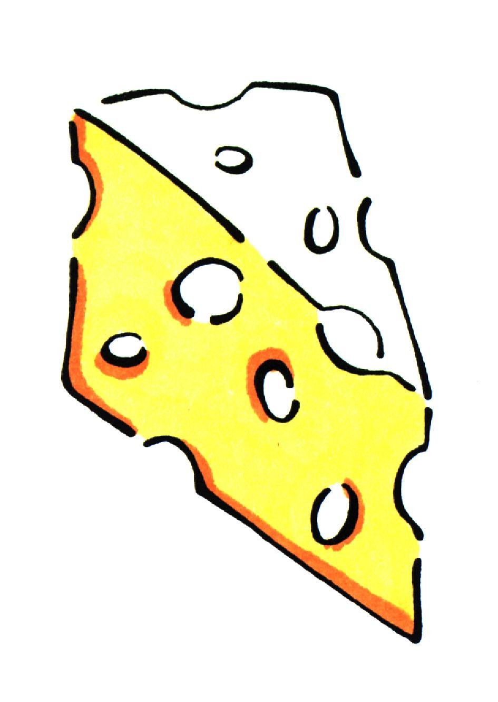

Cheese Enchildadas

Women Infants and Children ingredients: cheese

Utensils needed: |  |  | Ingredients needed:
measuring cups  measuring spoons  2 mixing bowls  baking dish |  |  | 2 (16 oz.) cans  1 (24 oz.) jar  3 cups  1/3 c.  ½ t.  12 (6 inch) | Refried beans  Salsa, prepared and divided  Cheddar, Monterey Jack and Mozzerella cheese divided  Green onions, thinly sliced  Cumin, ground  Tortillas
Step 1  Step 2  Step 3  Step 4 | Combine beans, 1 cup salsa, 1 ½ cups cheese, green onions and cumin in medium bowl.  Spread 1 cup salsa onto bottom of 9 X 13 inch baking dish.  Spoon a heaping 1/3 cup bean mixture down the center of each tortilla. Place tortillas, seam side down, on salsa. Top with remaining salsa and cheese.  Bake at 350º for 30 minutes or until thoroughly heated. Serve with sliced black olives, sliced green onions and sour cream.
Talk to your infant/toddler |  |  | Explore with your Toddler
DESCRIBE THINGS |  |  | SEE
The beans are all smashed up! |  |  | Look at all the colors mixed together.
 |  |  | HEAR
GIVE DIRECTIONS |  |  | Listen to the timer go off.
Can you stir the salsa and cheese? |  |  | TOUCH
 |  |  | Feel the mushy beans.
ASK QUESTIONS |  |  | TASTE
Is the enchilada too hot? |  |  | Taste the spicy salsa.

SMELL
Smell the cumin.

