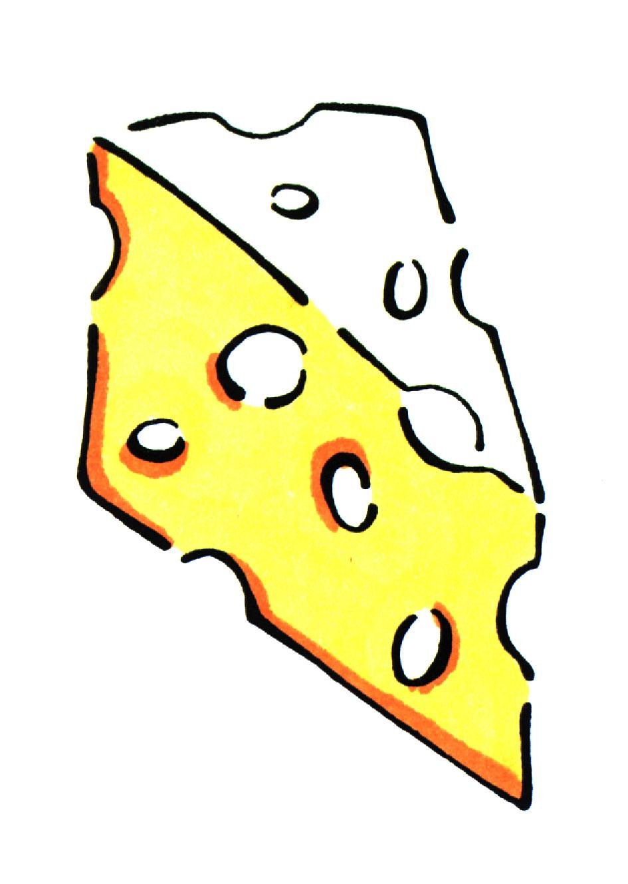

Cheese and Trees Soup

Women Infants and Children ingredients: cheese, produce from Farmer’s Market

Utensils needed: |  |  | Ingredients needed:
measuring cups  measuring spoons  2 mixing bowls  saucepan |  |  | 1 T.  1 c.  1 1/3 lb.  2 ½ c.  2  1 (10 oz.) pkg.  1 ½ c. |  | Butter  Onion, chopped  Potatoes, cut into ¾ inch cubes  Water  Vegetable bouillon cubes  Broccoli, thawed and drained  Cheddar cheese  Pepper and salt
Step 1  Step 2  Step 3  Step 4  Step 5  Step 6 | In 2-3 quart saucepan over medium heat, melt butter. Add onion and sauté 5 minutes. Add potatoes, water and bouillon cubes.  Bring to boil, reduce heat, cover and cook until potatoes are tender, about 15 minutes.  Remove 1 cup of potato cubes with slotted spoon and set aside. Pour contents of saucepan into container of electric blender.  Blend until smooth and return to saucepan.  Mix in the reserved potatoes and broccoli. Over medium-low heat gradually add cheese, stirring until heated through and cheese is completely melted.  Season with salt and pepper.
Talk to your infant/toddler |  |  |  | Explore with your Toddler
DESCRIBE THINGS |  |  |  | SEE
The cheese is orange. |  |  |  | Look at the broccoli “trees.”
 |  |  |  | HEAR
GIVE DIRECTIONS |  |  |  | Listen to the knife chopping the onions.
Wash all the dirt off the potatoes. |  |  |  | TOUCH
 |  |  |  | Feel the hard bouillon cubes.
ASK QUESTIONS |  |  |  | TASTE
Why do you think people call broccoli “trees”? |  |  |  | Taste the soup.
SMELL
Smell the onions.

