


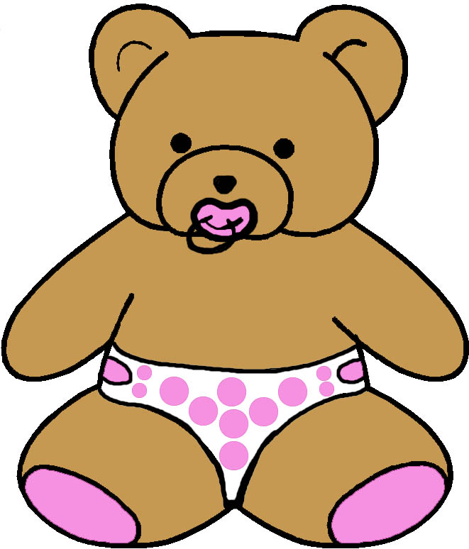
EV ELOPMENTAL MONITORING VER IME…

0 to 3 MONTHS
MASTERY MOTIVATION | SOCIAL PLAY | BABY GAMES | EXPLORATORY PLAY | BOOK PLAY | SCRIBBLE PLAY
INTEREST  - Orients to novel sights  - Orients to novel sounds  - Orients to novel touch  - Orients to novel smells  PERSISTENCE  - Maintains focused attention to people  - Continues to look toward a removed object  INDEPENDENCE  - Performs defensive movements  - Cries to gain attention  - Goes to sleep alone  AFFECT DURING PLAY  - Smiles with pleasure during social play  - Plays contentedly without fussing | ATTACHMENT  - Regards face  - Listens to parent’s voice  - Recognizes parent  - Calms best for parent  SELF AWARENESS  - Cries to seek attention  - Differentiates cries  - Looks at own hands  - Plays with own hands  SOCIAL AWARENESS  - Likes being held  - Enjoys being with people  - Responds to being talked to by parent  SENSE OF HUMOR  - Establishes eye contact  - Smiles responsively | CLAPPING  - Orients to people  - Becomes excited when parent approaches  - Smiles to clapped “yea”  PEEK-A-BOO  - Smiles responsively  - Moves head to remove cloth from face  - Responds to “boo”  BOUNCING AND LIFTING  - Smiles during bouncing and lifting movements  - Anticipates repeated body movement  TICKLING AND BODY PART  - Enjoys body being touched  - Habituates to repeated stimuli | LOOKING  - Looks at face  - Looks at toy  - Alternates glace between two toys  LISTENING  - Alerts to voice  - Alerts to sound  - Calms to music  - Gets used to noise  TOUCHING  - Touches caregiver’s face  - Bats at toy  - Touches toy with help  - Responds to textures  TASTING  - Sucks fingers or thumb  - Sucks pacifier | HANDLING  - Touches book with random hand movements  VISUAL ATTENTION  - Looks briefly at book  - Looks at pictures adult points to  - Watches speaker’s face  AUDITORY ATTENTION  - Orients to parent’s voice during book play  - Calms to voice and appears to listen  EMERGENT LITERACY  - Attracted to black and white patterns first  - Looks at red and white colors next | GRASP  - Looks at own hands  - Bats at object  - Releases object spontaneously  TOOL AWARENESS  - Shows interest in movement of objects  - Follows up, down and sideways  PAPER AWARENESS  - Bats at newspaper  - Notices light paper on dark background  CREATIVITY  - Focuses on moderately novel stimuli  - Open to new experiences
COMMUNICATION | MUSIC PLAY | SNACK PLAY | PLAY WITH TOYS | SENSORY PLAY | MOVEMENT
SOUND MAKING  - Produces nasalized cry  - Produces nasalized vowel sounds  EXPRESSIVE LANGUAGE  - Vocalizes in response to other’s vocalizations  - Begins to imitate vocalizations  RECEPTIVE LANGUAGE  - Displays awareness of parent’s voice  - Differentiates angry and pleasant voices  BABY SIGNS  - Attends to gesture with animated voice cue | RHYTHMIC ABILITIES  - Listening to heart beat  - Enjoys listening to music with a beat  - Calms to patting  INSTRUMENT USAGE  - Bats at or randomly kicks musical toy  - Differentiates responses to contrasting sounds  SINGING  - Produces vocalizations in response to adult singing  - Enjoys adult singing  - Quiets to lullaby  DANCING  - Smiles in response to playful movement  - Adjusts body when dancing with parent | ORAL MOTOR  - Uses suck swallow pattern  - Manages liquids with minimal loss  DRINKING  - Opens mouth when lips are stimulated  - Nurses or drinks from a bottle well  EATING  - Eats no solid foods  - Watches adult eating  - Reacts to strong food smells  SELF HELP  - Anticipates feeding with visual cues  - Adjusts head and body when in nursing position | SQUEAK TOYS RATTLES  - Orients to toy when it makes sound  - Allows stuffed animal o be placed in hand  STUFFED ANIMALS  - Touches stuffed animal with adult guidance  - Focuses briefly on moving stuffed animal  BLOCKS AND CUPS  - Orients to blocks when banged together  - Follows brightly colored moving block  BUSY TOYS  - Orients to spectacle of cause and effect toy  - Habituates to repeated stimuli | CUDDLING TIME  - Quiets to darkened room  - Molds body to caregiver  - Enjoys hearing lullaby  - Responds to loving touch  INFANT MASSAGE  - Anticipates massage  - Enjoys being touched  - Adjusts body to massage  TEXTURE EXPLORATION  - Touches textures with adult guidance  - Responds to different textures  HAND USAGE  - Puts hand in sensory medium with adult guidance  - Moves hand randomly | BALANCE  - Lifts and rotates head while lying on stomach  - Bobs head in pull to sit  - Adjusts to being held  STRENGTHENING  - Takes weight on forearms in prone  - Takes weight on legs in standing  MOVEMENT  - Moves arms randomly  - Kicks legs randomly  - Turns head back and forth  VESTIBULAR  - Calms when parent rocks side to side  - Enjoys being rocked  - Relaxes to swaddling

