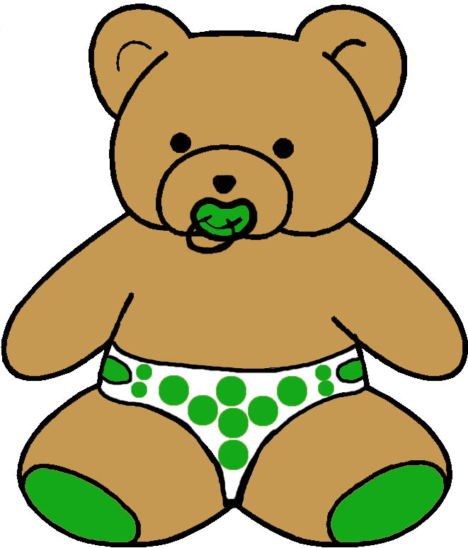



EVELOPMENTAL MONITORING VER IME …
12 to 18 MONTHS
MASTERY MOTIVATION | SOCIAL PLAY | PROBLEM SOLVING PLAY | PRETEND PLAY | BOOK PLAY | SCRIBBLE PLAY
INTEREST  - Demonstrates eagerness to become involved with a task  - Stops to look closely  PERSISTENCE  - Maintains focused attention to toys  - Show persistence with preferred tasks  INDEPENDENCE  - Tries first before asking for help  - Engages in challenging tasks independently  AFFECT DURING PLAY  - Smiles with pleasure when engaged in a task  - Smiles with pleasure upon completing a task | ATTACHMENT  - Shows affection to parent  - Depends on adult’s presence  - Checks back with adult  SELF AWARENESS  - Enjoys an audience  - Likes to look in mirror  - Seeks independence  - Resists adult control  SOCIAL AWARENESS  - Takes turns with partner  - Shows or offers toy  - Stops briefly to “ no”  - Waves goodbye on own  SENSE OF HUMOR  - Shows sense of humor  - Laughs at oddities  - Repeats performance laughed at | CAUSALITY  - Attempts to activate simple mechanism  - Uses adult as means to activate toy  PROBLEM SOLVING STYLE  - Uses non systematic trail and error  - Demonstrates increased awareness of dissonance  CLASSIFICATION  - Picks up like objects in each hand in play  - Selects object misplaces in array of like objects  MEMORY  - Maintains goal without being distracted  - Enjoys losing and finding games | IMITATION  - Enjoys imitating adults  - Imitates novel behaviors and movements  - Begins deferred imitation  ROLES  - Directs pretend actions to self  - Directs pretend actions to adult  ACTIONS  - Uses one pretend action  - Uses same pretend action on two things  - Models two actions  OBJECTS  - Inspects objects first and then plays with them  - Pretends using real props  - Sits on doll furniture | HANDLING  - Holds book by cover  - Flips pages  - Lifts flaps in book  - Explores textures in book  VISUAL ATTENTION  - Shifts gaze to point  - Attends to details  - Does not notice when book is upside down  AUDITORY ATTENTION  - Attends to rhyme  - Repeats novel sounds  - Repeats single words  - Listens to part of story  EMERGENT LITERACY  - Enjoys sharing book  - Chooses book play  - Has a favorite book  - Puts pencil to paper | GRASP  - Uses fisted grasp  - Switches utensil from hand to hand  - Has no hand dominance  TOOL USAGE  - Prefers fat brush, crayon, marker or pencil  - Moves arm as whole  PAPER USAGE  - Starts to watch drawing process  - Disregards boundaries  - Does not stabilize paper  REPRESENTATIONAL ABILITY  - Sees crayons as toys  - Makes random marks and scribbles  - Looks at name with cue
COMMUNICATION PLAY | MUSIC PLAY | SNACK PLAY | BLOCK PLAY | MESSY PLAY | ACTIVE PLAY
VOCABULARY  - Has a vocabulary of 15 words at 18 months  - Understands 50 words  - Imitates new words  DIRECTION FOLLOWING  - Follows one step directions  - Identifies 2 to 6 body parts  QUESTIONS  - Answers where and what questions  - Begins to respond to yes and no questions  PRAGMATICS  - Points to, shows or gives objects  - Uses words to protest  - Initiates turn taking | RHYTHMIC ABILITIES  - Imitates clapping  - Moves to a beat  - Responds to emotional tone of music  INSTRUMENT USAGE  - Shakes musical toy  - Bangs drum with hand  - Imitates adult use of musical toy with prompt  SINGING  - Recognizes familiar tunes  - Tries to sing along to familiar song  - Enjoys parent singing  DANCING  - Bounces and moves to music  - Imitates novel dance movements | ORAL MOTOR  - Transfers food from center to side of mouth  - Uses tongue tip elevation for eating and drinking  CUP USAGE  - Closes lips when swallowing liquids  - Bites down on edge of cup to stabilize  UTENSIL USAGE  - Uses spoon with some spilling  - Finger feeds independently  SELF HELP  - Refuses foods at times  - Throws paper plate into garbage with visual and physical prompting | STACKING  - Carries blocks around  - Puts blocks in and out of container  - Stacks 2 to 3 blocks high  NESTING AND FITTING  - Takes apart nested cups  - Combines two cups  - Puts pieces in puzzle randomly  PLANNING  - Stacks without planning  - Combines nesting objects without planning  - Enjoys knocking over  REPRESENTATION ABILITY  - Builds with blocks  - Pretends with blocks with adult guidance | GRASP  - Grasps and releases objects  - Approaches messy textures with caution  TOOL USAGE  - Uses hands to explore messy substances  - Rakes through messy substances with tools  PURPOSEFULNESS  - Explores messy substance with senses  - Enjoys process of sensory exploration  TEXTURE EXPLORATION  - Explores a variety of sensory mediums including wet, dry, rough, and smooth substances | BALANCING  - Squats in play  - Stoops and recovers  - Balances on knees  - Stands up from sitting  MOVING  - Walks without support  - Runs with arms raised  - Walks sideways  - Walks backwards  CLIMBING  - Climbs into chair to sit  - Creeps up stairs with supervision  BALL SKILLS  - Rolls a large ball  - Catches a large rolled ball  - Enjoys back and forth ball play with adult

