
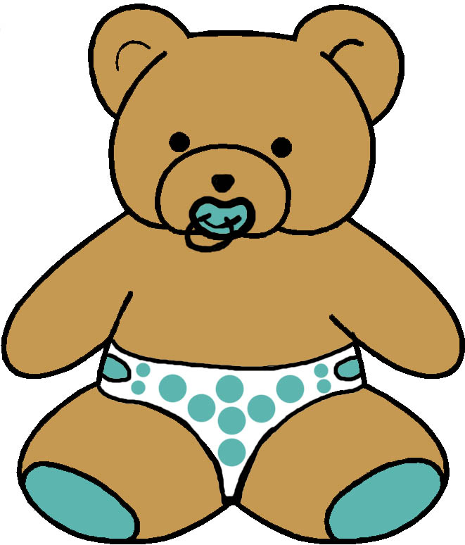


EVELOPMENTAL MONITORING VER IME…
18 to 24 MONTHS
MASTERY MOTIVATION | SOCIAL PLAY | PROBLEM SOLVING PLAY | PRETEND PLAY | BOOK PLAY | SCRIBBLE PLAY
INTEREST  - Demonstrates eagerness to become involved with task  - Stops to look closely  PERSISTENCE  - Maintains focused attention to toys  - Show persistence with preferred tasks  INDEPENDENCE  - Tries first before asking for help  - Engages in challenging tasks independently  AFFECT DURING PLAY  - Smiles with pleasure when engaged in task  - Smiles with pleasure upon completing task | ATTACHMENT  - Hugs and kisses parent  - Clings to parent at times  - Handles brief separations from parent  SELF AWARENESS  - Insists on independence  - Recognizes self in mirror  - Recognizes self in photos  - Uses no and mine  SOCIAL AWARENESS  - Likes to please others  - Sees emotions in others  - Tries to comfort others  - Plays near other children  SENSE OF HUMOR  - Laughs at self initiated silliness  - Substitutes one object for another in pretend | CAUSALITY  - Uses adults to activate cause and effect toys  - Activates simple cause and effect toys  PROBLEM SOLVING STYLE  - Uses trial and error strategizing  - Uses tool to reach object  - Points to desired object  CLASSIFICATION  - Clusters similar objects  - Selects object misplaced in array of like objects  - Figures out shape sorter  MEMORY  - Uses environmental cues to anticipate events  - Increases memory for location | IMITATION  - Imitates something previously seen  - Varies own imitation creatively from model  ROLES  - Attributes to doll the ability act  - Includes self and partner in same pretend action  ACTIONS  - Combines two toys in pretend play  - Uses two related pretend actions in sequence  OBJECTS  - Pretends with realistic objects  - Uses own body to pretend (hops as bunny) | HANDLING  - Turns pages singly  - Lifts flaps  - Explores textures  - Holds book appropriately  VISUAL ATTENTION  - Searches for favorite picture in book  - Turns book right side up  - Recognizes illustrations  AUDITORY ATTENTION  - Shows interest in rhyme  - Imitates short phrases  - Answers what questions  - Listens to short story  EMERGENT LITERACY  - Has favorite books  - Brings book to parent  - Attends to print pointed out in the environment | GRASP  - Grasps crayon between fingers and thumb  - Uses one hand without strong preference  TOOL USAGE  - Prefers fat brush, crayon, marker, or pencil  - Shifts action to wrist and lower arm  PAPER USAGE  - Looks at paper during drawing process  - Begins to anchor paper with free hand  REPRESENTATIONAL ABILITY  - Represents actions in drawings (zip and zoom)  - Draws lines and circles  - Watches name written
COMMUNICATION PLAY | MUSIC PLAY | SNACK PLAY | BLOCK PLAY | MESSY PLAY | ACTIVE PLAY
VOCABULARY  - Uses up to 50 words  - Uses two word phrases  - Shows interest in the names of things  DIRECTION FOLLOWING  - Follows two commands with one object  - Follows novel command with visual cue  QUESTIONS  - Answers what , where, yes and no questions  - Identifies body parts  - Starts to say okay  PRAGMATICS  - Uses vocalizations and words during play  - Takes turns talking during conversations | RHYTHMIC ABILITIES  - Claps and moves to a beat  - Responds to emotional tone of music  INSTRUMENT USAGE  - Bangs a drum with a stick  - Recognizes how to use musical toy  - Starts to keep a beat  SINGING  - Enjoys a variety of types of music  - Hums and sings to music  - Sings along with parent  DANCING  - Dances to music varying movement to beat  - Seeks to dance with parent | ORAL MOTOR  - Licks lips to clear off food  - Chews with minimal loss of food  CUP USAGE  - Holds cup with one hand  - Sets down cup after drinking  - Has a favorite cup  UTENSIL USAGE  - Uses spoon with little spilling  - Has a favorite spoon  SELF HELP  - Sits in chair independently to eat  - Throws away paper plate and cup with prompt | STACKING  - Stacks 4 to 6 blocks high  - Stacks random objects  - Explores connecting blocks randomly  NESTING AND FITTING  - Inverts nesting cups  - Nests 2 to 4 cups with verbal and visual cues  - Puts 3 pieces in puzzle  PLANNING  - Knocks over to rebuild  - Uses trial and error strategizing  - Goes to block area  REPRESENTATION ABILITY  - Adds figures to block play with adult model  - Builds wall, house, pen, or train with adult | GRASP  - Uses both hands at midline  - Rolls, pounds and squeezes playdoh  TOOL USAGE  - Hold two objects  - Uses tools for scooping and pouring sensory material  PURPOSEFULNESS  - Enjoys process of sensory exploration  - Uses novel materials added to sensory table  TEXTURE EXPLORATION  - Explores a variety of sensory mediums including wet, dry, rough, and smooth substances | BALANCING  - Picks up toy from floor without falling  - Stands on tiptoes  - Tries to stand on one foot  MOVING  - Runs fairly well  - Moves riding toy using legs  - Pulls toy along  CLIMBING  - Climbs into adult chair to sit down  - Walks up stairs two feet per step with hand held  BALL SKILLS  - Throws ball into box  - Kicks ball forward  - Enjoys ball play with an adult

