


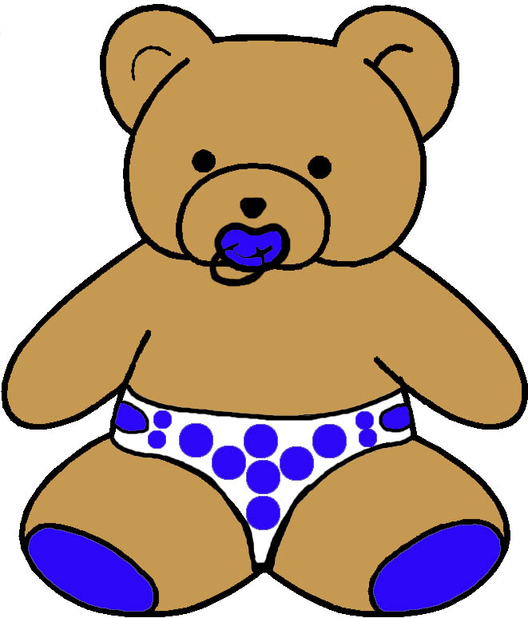
EVELOPMENTAL MONITORING VER IME…
24 to 30 MONTHS
MASTERY MOTIVATION | SOCIAL PLAY | PROBLEM SOLVING PLAY | PRETEND PLAY | BOOK PLAY | SCRIBBLE PLAY
AROUSAL  - Demonstrates eagerness to become involved with task  - Stops to look closely  PERSISTENCE  - Maintains focused attention to toys  - Show persistence when engaged in tasks  INDEPENDENCE  - Tries first before asking for help  - Engages in challenging tasks independently  AFFECT DURING PLAY  - Smiles with pleasure when engaged in task  - Smiles with pleasure upon completing task | ATTACHMENT  - Hugs and kisses parent  - Loves to share discoveries  - Loves being watched  SELF AWARENESS  - Says me and mine  - Demands independence  - Has pride in possessions  - Refers to self by name  SOCIAL AWARENESS  - Shows empathy  - Aware of adult standards  - Smiles and looks at other children  SENSE OF HUMOR  - Makes first joke by calling something by the wrong name  - Starts to tease adults | CAUSALITY  - Understands if then logic  - Activates a variety of types of mechanisms  PROBLEM SOLVING STYLE  - Uses trial and error with foresight emerging  - Corrects behavior to match adult standard  CLASSIFICATION  - Matches objects by color, shape, size  - Recognizes parts and wholes  MEMORY  - Begins to think about past events  - Requests distant and absent objects | IMITATION  - Represents own daily experiences  - Imitates actions of others  - Puts on accessories  ROLES  - Assumes various roles  - Talks to play figures  - Can take reciprocal roles in pretend play  ACTIONS  - Uses three to five related pretend play actions  - Narrates play with pretend play toys  OBJECTS  - Performs simple symbol substitutions  - Searches for objects needed for play | HANDLING  - Looks at book page by page  - Gets book to read  VISUAL ATTENTION  - Relates pictures to real objects  - Imitates actions in book  AUDITORY ATTENTION  - Repeats rhyming words  - Chimes in with reader  - Listens to short story without distraction  EMERGENT LITERACY  - Brings book to parent  - Likes books read over  - Notices print in environment | GRASP  - Uses index finger for control utensil  - Picks up tool and rotates it to proper position  TOOL USAGE  - Uses thin brush, crayon, marker, or pencil  - Applies tape and glue with assistance  PAPER USAGE  - Focuses on drawing  - Holds paper steady with free hand  - Folds paper  REPRESENTATIONAL ABILITY  - Draws pictures with adult  - Notices and labels forms in scribbles  - Makes mark for name
COMMUNICATION PLAY | MUSIC PLAY | SNACK PLAY | BLOCK PLAY | MESSY PLAY | ACTIVE PLAY
VOCABULARY  - Produces 50 to 300 words  - Uses nouns and verbs  - Uses two to three word phrases  DIRECTION FOLLOWING  - Completes two part command  - Follows novel command with visual cue  QUESTIONS  - Answers what, where, and what doing questions  - Asks simple questions  PRAGMATICS  - Knows names of and greets playmates  - Commands others  - Expresses feelings | RHYTHMIC ABILITIES  - Claps and moves to a beat  - Responds to emotional tone of music  INSTRUMENT USAGE  - Plays toy piano  - Imitates a drum beat  - Uses instrument to accompany song  SINGING  - Turns on favorite CD or tape with help  - Recalls parts of songs  - Likes to learn new songs  DANCING  - Dances holding doll or bear  - Imitates adult gestures to accompany songs | ORAL MOTOR  - Bites into varied foods  - Chews and swallows appropriately  - Blows bubbles with wand  CUP USAGE  - Sucks through a straw  - Drinks from a cup with no difficulty  - Has a favorite cup  UTENSIL USAGE  - Uses spoon with minimal spilling  - Uses a fork  SELF HELP  - Eats snack independently  - Wipes mouth with napkin with verbal cue | STACKING  - Stacks 6 to 8 blocks high  - Fits simple connecting blocks together  - Stacks household items  NESTING AND FITTING  - Nests 3 to 4 cups  - Inverts and stacks nesting cups  - Fits 5 to 6 pieces in puzzle  PLANNING  - Uses train and error with self correction  - Seeks specific blocks for play  REPRESENTATION ABILITY  - Adds figures to block play  - Imitates a 4 block train  - Starts to build structures | GRASP  - Moves small objects from finger to palm  - Picks up tool and rotates it for appropriate use  TOOL USAGE  - Uses tools to scoop and pour into containers  - Fills containers with large openings  PURPOSEFULNESS  - Combines sensory materials with pretend play props  - Talks about play actions  TEXTURE EXPLORATION  - Explores a variety of sensory mediums including wet, dry, rough, and smooth dimensions | BALANCING  - Jumps in place with both feet  - Imitates standing on one foot  MOVING  - Runs, avoids obstacles, and stops  - Uses legs to move riding toy back and forth  CLIMBING  - Pushes up chair to climb  - Goes up and down slide  - Walks up and down stairs alone  BALL SKILLS  - Throws a small ball over and under handed  - Catches a large ball with both hands

