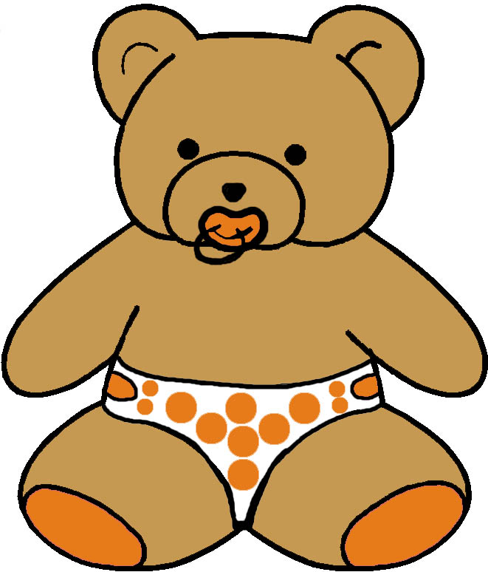



EVELOPMENTAL MONITORING VER IME…
6 to 9 MONTHS
MASTERY MOTIVATION | SOCIAL PLAY | BABY GAMES | EXPLORATORY PLAY | BOOK PLAY | SCRIBBLE PLAY
INTEREST  - Begins to actively explore the environment  - Uses several actions to explore objects  PERSISTENCE  - Explores toys in depth  - Furrows brow in concentration  - Acts to achieve an effect  INDEPENDENCE  - Readies body for familiar activities  - Acts to achieve an effect  - Plays alone in crib  AFFECT DURING PLAY  - Smiles with pleasure during play with toys  - Enjoys social games | ATTACHMENT  - Seeks to be with parent  - Shows anxiety over separation from parent  - Shows fear of strangers  SELF AWARENESS  - Recognizes own name  - Vocalizes to self in mirror  - Responds to “no”  - Protests when unhappy  SOCIAL AWARENESS  - Initiates interactions  - Reacts to expressions  - Waves good bye  - Knows familiar people  SENSE OF HUMOR  - Repeats amusing sounds  - Demonstrates awareness of differences  - Finds siblings funny | CLAPPING  - Raises arms to clap in response to gesture  - Claps at midline  - Enjoys collaborative play  PEEK-A-BOO  - Actively participates in peek-a-boo game  - Demonstrates joint attention to a hidden toy  BOUNCING AND LIFTING  - Responds to familiar phrase in game  - Enjoys frolic play  - Wants games continued  TICKLING AND BODY PART  - Prepares for climax in tickle games  - Actively cooperates with body part games | LOOKING  - Looks at toy with parent  - Uncovers hidden toy  - Fixates on very small objects  LISTENING  - Localizes sounds  - Gives up object when asked  - Gets used to noise  TOUCHING  - Rakes at small objects  - Transfers objects  - Handles different types of objects differently  TASTING  - Brings objects to mouth  - Alternates mouthing with looking and touching  - Brings feet to mouth | HANDLING  - Plays with pages like a hinge toy  - Turns pages with help  - Holds and mouths book  VISUAL ATTENTION  - Shifts attention between named pictures  - Uses eyes and hands  - Prefers real photographs  AUDITORY ATTENTION  - Quiets for story time  - Listens to story  - Enjoys novel sounds made by reader  EMERGENT LITERACY  - Looks at pictures and photos of actual objects  - Begins to have a favorite book | GRASP  - Uses raking grasp  - Reaches for second toy  - Adjusts hand when reaching for object  TOOL AWARENESS  - Attempts to secure object out of reach  - Transfers object hand to hand  PAPER AWARENESS  - Attends to scribbling on paper  - Shakes, waves, and pulls paper  CREATIVITY  - Enjoys novel stimuli  - Attends to sights and sounds that adult points out in environment
COMMUNICATION PLAY | MUSIC PLAY | SNACK PLAY | PLAY WITH TOYS | SENSORY PLAY | MOVEMENT PLAY
SOUND MAKING  - Babbles  - Imitates raspberries  - Varies intonation  - Imitates exclamations  EXPRESSIVE LANGUAGE  - Vocalizes with intent  - Takes turns vocalizing  - Imitates facial expressions  RECEPTIVE LANGUAGE  - Recognizes names of family members  - Responds to a simple request with gesture  BABY SIGNS  - Uses gestures to gain attention of another  - Watches adults make baby signs | RHYTHMIC ABILITIES  - Attends to poem read  - Claps hands to rhyme  - Enjoys listening to music  - Calms to nature sounds  INSTRUMENT USAGE  - Acts directly on simple musical toy  - Looks for how bell works  - Enjoys listening to music  SINGING  - Vocalizes to music  - Is comforted by singing  - Reacts if adult stops singing  DANCING  - Spontaneously moves body to music  - Enjoys dancing with parent | ORAL MOTOR  - Manages liquids, cereals, pureed, ground, or mashed table foods  - Munches and chews  DRINKING  - Nurses  - Drinks from a bottle  - Drinks from a cup when held  EATING  - Bites off piece of solid food  - Finger feeds cheerio  SELF HELP  - Holds bottle  - Drinks from cup with assistance | SQUEAK TOYS RATTLES  - Performs several action patterns with toys  - Holds toy in each hand  - Transfers hand to hand  STUFFED ANIMALS  - Uncovers partially hidden stuffed animal  - Pokes at facial features of stuffed animal  BLOCKS AND CUPS  - Drops block into cup  - Takes block out of cup  - Transfers block hand to hand  BUSY TOYS  - Acts directly on toy to have an effect  - Repeats actions  - Pokes fingers in holes | CUDDLING TIME  - Quiets to darkened room  - Molds body to caregiver  - Enjoys hearing lullaby  - Responds to loving touch  INFANT MASSAGE  - Anticipates next step in massage routine  - Gives eye contact and vocalizes with massage  TEXTURE EXPLORATION  - Coordinates looking and reaching  - Recognizes familiar and novel textures  HAND USAGE  - Puts hands in sensory medium  - Moves fingers to explore  - Plays at midline | BALANCE  - Shifts weight on arms to obtain a toy  - Sits with legs in ring position  STRENGTHENING  - Bears weight on extended arms  - Bears weight on legs  - Bounces in standing  MOVEMENT  - Rolls back and forth  - Pivots and rotates trunk  - Flings objects  - Creeps or crawls  VESTIBULAR  - Rocks back and forth in crawling position  - Enjoys being rocked  - Enjoys park baby swing

