


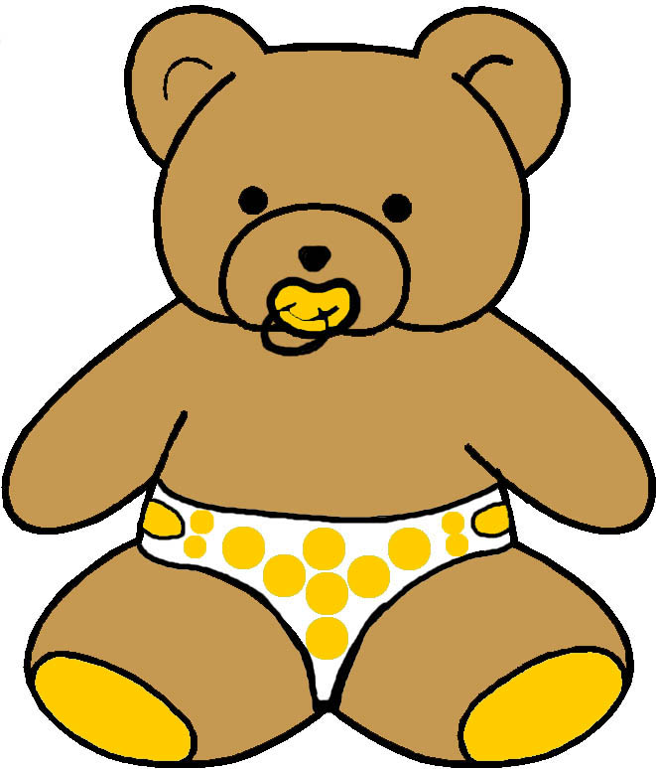
EVELOPMENTAL MONITORING VER IME…

9 to 12 MONTHS
MASTERY MOTIVATION | SOCIAL PLAY | BABY GAMES | EXPLORATORY PLAY | BOOK PLAY | SCRIBBLE PLAY
INTEREST  - Actively explores the environment  - Purposefully chooses toys to explore in depth  PERSISTENCE  - Goes around barrier to obtain desired object  - Uses different behaviors to reach goal  INDEPENDENCE  - Explores at increasing distance from parent  - Attempts tasks before seeking assistance  AFFECT DURING PLAY  - Smiles with pleasure upon reaching goal  - Show surprise at novel stimuli | ATTACHMENT  - Says mama and dada  - Shows affection  - Shows fear of strangers  - Fears separations  SELF AWARENESS  - Responds to own name  - Smiles at self in mirror  - Has likes and dislikes  - Inhibits on command  SOCIAL AWARENESS  - Initiates interactions  - Mirrors parent’s emotions  - Waves hi and bye  - Takes turns with partner  SENSE OF HUMOR  - Shows surprise  - Repeats performance laughed at by others  - Develops sense of humor | CLAPPING  - Initiates clapping games  - Claps at midline  - Enjoys collaborative play  - Claps to rhyme  PEEK-A-BOO  - Initiates peek-a-boo game  - Finds hidden parent  - Seeks hidden toy  BOUNCING AND LIFTING  - Responds to familiar phrase in game  - Enjoys frolic play  - Wants games continued  TICKLING AND BODY PART  - Knows routine of tickle game and plays along  - Anticipates actions in body part game | LOOKING  - Looks at toy with adult  - Uncovers hidden toy  - Turns and examines toy  - Tilts head to look  LISTENING  - Listens to people talking  - Activates musical toy  - Attends to speaker and object simultaneously  TOUCHING  - Points and pokes  - Picks up tiny object  - Uses objects functionally  - Enjoys dropping games  TASTING  - Occasionally mouths novel toys  - Mouths toys of a preferred texture | HANDILING  - Turns pages with adult guidance  - Explores textures in book with cue  VISUAL ATTENTION  - Shifts gaze to adult point  - Attends to details  - Looks at correct distance  - Recognizes familiar book  AUDITORY ATTENTION  - Points to picture named  - Quiets for reading time  - Enjoys novel sounds  - Listens to story briefly  EMERGENT LITERACY  - Attends to adult reading  - Attends to adult writing  - Enjoys reading time  - Grabs at adult’s pen | GRASP  - Uses pincer grasp  - Releases voluntarily  - Adjusts hand when reaching for object  TOOL AWARENESS  - Attempts to secure object out of reach  - Pulls cloth to obtain toy  - Pulls string to obtain toy  PAPER AWARENESS  - Attends to scribble on paper  - Tears paper  - Puts crayon to paper  CREATIVITY  - Enjoys novel stimuli  - Attends to sights and sounds that adult points out in environment
COMMUNICATION PLAY | MUSIC PLAY | SNACK PLAY | PLAY WITH TOYS | SENSORY PLAY | MOVEMENT PLAY
SOUND MAKING  - Mixes babbling sounds with jargon  - Experiments with sounds, inflections, and pitch  EXPRESSIVE LANGUAGE  - Imitates environmental sounds  - Says mama or dada  - Imitates expressions  RECEPTIVE LANGUAGE  - Recognizes names of family, pets, and toys  - Follows simple commands  BABY SIGNS  - Uses gestures to communicate  - Imitates baby signs  - Uses baby signs | RHYTHMIC ABILITIES  - Prefers music with a beat  - Claps hands to music  - Has favorite rhyme  - Calms to poetry  INSTRUMENT USAGE  - Activates various types of musical toys  - Looks for how bell works  - Enjoys listening to music  SINGING  - Vocalizes along to familiar song  - Reacts to stopped song  - Enjoys parent singing  DANCING  - Moves hands and body to music  - Imitates familiar dance movements | ORAL MOTOR  - Manages pureed, ground, mashed, and chunky foods  - Starts to chew foods  DRINKING  - Nurses  - Drinks from bottle  - Drinks from cup when held  EATING  - Bites off piece of solid food  - Finger feeds  - Has likes and dislikes  SELF HELP  - Holds bottle independently  - Drinks from cup with help  - Uses spoon with help | SQUEAK TOYS RATTLES  - Shows toy to adult  - Imitates novel actions with objects  - Uncovers hidden toy  STUFFED ANIMALS  - Unwraps hidden toy  - Pokes at facial features  - Reorients upside down stuffed animal  BLOCKS AND CUPS  - Holds two blocks in hand  - Puts blocks in and out  - Bangs blocks together  - Stacks one block on top  BUSY TOYS  - Interested in action toys  - Uses adult’s hand to activate busy toy  - Reaches for toy in mirror | CUDDLING TIME  - Quiets to darkened room  - Molds body to caregiver  - Enjoys hearing lullaby  - Responds to loving touch  INFANT MASSAGE  - Readies in response to visual or verbal cue  - Knows next step in massage routine  TEXTURE EXPLORATION  - Coordinates looking and reaching  - Recognizes familiar and novel textures  HAND USAGE  - Puts hands in sensory medium  - Moves fingers to explore  - Plays at midline | BALANCE  - Sits and plays with toys  - Pulls to stand  - Stands alone  - Throws ball  STRENGTHENING  - Moves from sit to crawl  - Bounces in standing  - Plays in kneeling position  - Cruises around furniture  MOVEMENT  - Crawls to explore  - Cruises around furniture  - Walk with push cart  - Starts to walk alone  VESTIBULAR  - Rocks back and forth in crawling position  - Likes rocking, swinging and riding along

