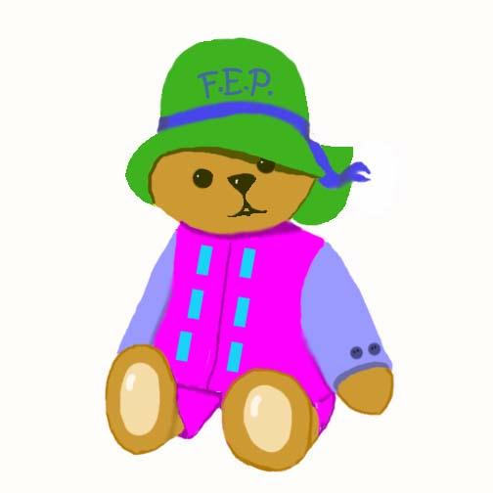

Name/Nombre Date/Fecha__________________

TEN THINGS EVERY CHILD NEEDS
Interaction Loving Touch Stable Relationship Safety and Health Self Esteem
Quality Child Care Communication Play Music Reading
 | Goals  Metas | Plan of action  Plan de acción | What happened?  ¿Que sucedió?

Children/Niños

Health/Salud
Family/Familia
TEN THINGS EVERY PARENT NEEDS
Child Development Information Positive Parenting Strategies Stress Management Father Involvement Creative Expression

Social Support Healthy Lifestyle Use of Community Resource Postive Parent Life Course Hope for the Future

Parents/Padres Date/Fecha__ ____

Teacher/Maestra _____
OFFICE/OFICINA 841-5950

