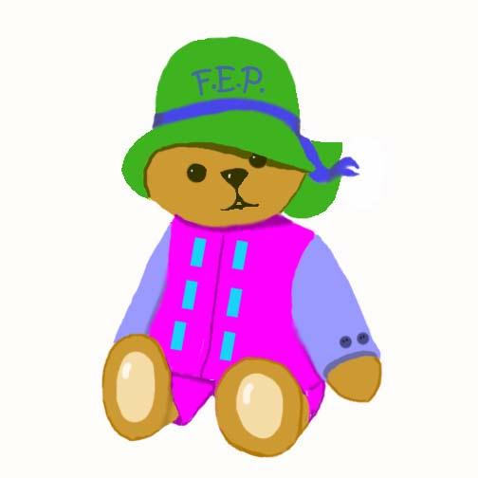

NAME___________________________ DATE_________________________

INTERACTION  to enjoy social games like peek-a-boo  to enjoy back and forth communication  to enjoy finger plays  to enjoy back and forth games like rolling a ball  to enjoy playing with peers | LOVING TOUCH  to enjoy hugs and kisses  to give hugs and kisses  to enjoy loving touch  to snuggle with parents  to have a teddy bear or comfort toy
STABLE RELATIONSHIP  to be attached to mother  to be attached to father  to enjoy siblings and close relatives  to be comfortable with a familar caregiver  to venture out and check back with loved one | SAFETY AND HEALTH  to receive well childcare  to live in a safe home environment  to try and eat a variety of nutritious foods  to have vision and hearing screened  to receive first dental screening
SELF-ESTEEM  to smile and be happy with self  to try things independently  to seek and enjoy praise from others  to be proud of accomplishments  to receive positive parenting | QUALITY CHILD CARE  to have stimulating toys  to have a safe place to explore  to get outside to play  to be with a variety of people  to have a trusted babysitter
COMMUNICATION  to live in a language rich environment  to express wants and needs  to communicate back and forth  to follow simple directions  to learn new words and have new experiences | PLAY  to engage in messy play  to engage in stacking and nesting play  to experiment with cause and effect toys  to engage in pretend play  to begin to sort, match, and do puzzles
MUSIC  to listen to a variety of music  to sing songs  to dance to music  to play with musical toys  to enjoy musical activities | READING  to be read to daily  to have access to books and crayons  to scribble or draw with parent daily  to see parents reading and writing  to visit the library regularly

Based on Ten Things Every Child Needs, The McCormick Tribune Foundation Education Program, 1998
Form: Child Needs 1/03

