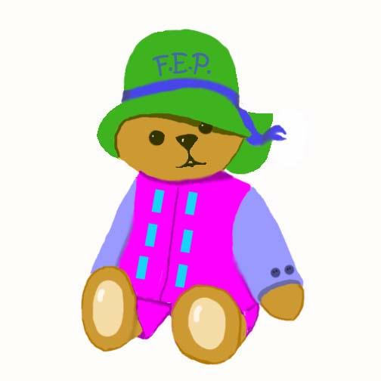

NAME_______________ DATE________________

CHILD DEVELOPMENT INFORMATION  to learn more about child development  to understand child behavior  to learn which toys and books are best  to support feeding,sleeping, and toileting behaviors  to feel confident in role as child’s primary teacher | SOCIAL SUPPORT  to make friends in the program  to make friends in the community  to explore options for community involvement  to have supportive relatives and friends  to have support from agencies or church
POSITIVE PARENTING STRATEGIES  to learn comforting and calming techniques  to find special time each day to enjoy child  to learn to build child’s self esteem  to learn positive ways to direct child behavior  to find alternatives to physical punishment | HEALTHY LIFESTYLE  to learn about nutrition  to exercise regularly  to change unhealthy habits  to learn about family planning  to choose a healthy lifestyle
STRESS MANAGEMENT  to learn assertiveness skills  to learn organizational skills  to learn anger management skills  to learn money management skills  to increase self-esteem | USE OF COMMUNITY RESOURCES  to become more involved at school  to find health care providers  to obtain counseling  to access needed services  to use park district and library resources
FATHER INVOLVEMENT  to improve parenting skills  to have special dad time for child  to parent as a team  to learn home improvement skills  to get a better job | POSITIVE PARENT LIFE COURSE  to explore their own childhood and its impact  to learn about computers  to enroll in an educational program  to seek job training  to feel at home in the community
CREATIVE EXPRESSION  to try some new creative things  to discover new talents  to create together with child  to share talents with others  to incorporate art and music into family life | HOPE FOR THE FUTURE  to have a vision for child’s future  to learn to set goals  to learn advocacy skills  to find employment  to always have hope for a better future
Ideas from The Future of Children, Home Visiting: Recent Program Evaluations, The Packard Foundation Spring/Summer 1999
ECHO Family Enrichment Program

