Family Enrichment Program
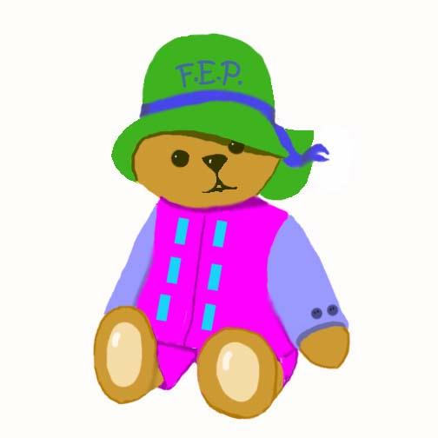
YEARLY CHILD/FAMILY OUTCOMES

CHILD OUTCOMES
INTERACTION, STABLE RELATIONSHIP, SELF-ESTEEM, COMMUNICATION, MUSIC, LOVING TOUCH, SAFETY AND HEALTH, QUALITY CHILD CARE, PLAY, READING

Disagree Agree
- My child enjoys learning through play with caregivers. 1 2 3 4 5
- My child has a special relationship with his/her caregivers. 1 2 3 4 5
- My child is happy and feels good about himself/herself. 1 2 3 4 5
- My child frequently hears and uses new sounds or words. 1 2 3 4 5
- My child has opportunities to sing, dance, and play with musical toys. 1 2 3 4 5
- My child enjoys giving and receiving hugs and kisses. 1 2 3 4 5
- My child receives health check-ups and shots regularly. 1 2 3 4 5
- My child has a safe and interesting environment to explore. 1 2 3 4 5
- My child engages in a variety of play activities daily, including
moving, exploring, pretending, and creating. 1 2 3 4 5
- My child loves sharing books with adults. 1 2 3 4 5

PARENT OUTCOMES
CHILD DEVELOPMENT INFORMATION, POSITIVE PARENTING STRATEGIES, STRESS MANAGEMENT, FATHER INVOLVEMENT, CREATIVE EXPRESSION, SOCIAL SUPPORT, HEALTHY LIFESTYLE, USE OF COMMUNITY RESOURCES, POSITIVE PARENT LIFE COURSE, HOPE FOR THE FUTURE

Disagree Agree
- I gained more understanding of child development. 1 2 3 4 5
- I learned new parenting skills. 1 2 3 4 5
- I learned more strategies to manage stress in my life. 1 2 3 4 5
- I share parenting with my partner. 1 2 3 4 5
- I tried something new and creative this year. 1 2 3 4 5
- I made more friends in my community. 1 2 3 4 5
- I am trying to maintain a healthy lifestyle. 1 2 3 4 5
- I know how to find and use community resources. 1 2 3 4 5
- I am furthering my own education. 1 2 3 4 5
- I have a positive vision for my family’s future. 1 2 3 4 5

FAMILY LEVEL OF PARTICIPATION
Percentage of available activities family attended:

⬇ ⬇⬇ ⬇⬇⬇ ⬇⬇⬇⬇
25% or less 25% to 50% 50% to 75% 75% to 100%

