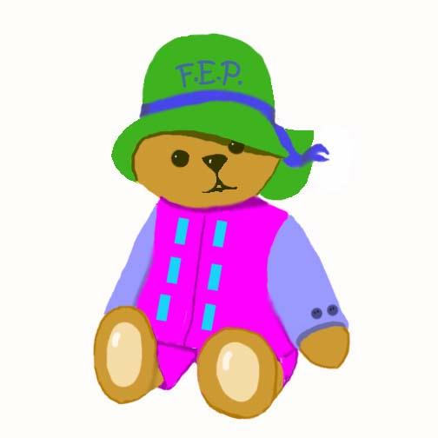

The Family Enrichment Program is an Early Education Program for children birth to three and their parents. Learning activities take place at MacArthur School, 640 East 168th Place, South Holland and at the 21st Century Preparatory Center, 240 South Orchard, Park Forest. Our offices are located at the Roosevelt Center, 320 East 161st Place, South Holland. The program offers the following activities:

- Play groups for infants and their parents
- Play groups for toddlers and their parents
- Parent informational support groups
- Home visits
- Family field trips

The goal of the Family Enrichment Program is to provide the learning foundations that will assure success in school and in life. Studies have shown that parents can increase their young child’s learning power by loving, playing, reading, singing and talking. Come join the fun!


Play and Learn

Child’s Name_______________________________________Date:_______________

Mother’s Name: __________________Father’s Name: _________________________

Child’s Birth Date: __________________Age:______________Gender:____________

Address: _____________________________________________________________

Telephone: _____________School District:_____Referred by: ___________________

Send form to the Family Enrichment Program, Roosevelt Center, 320 East 161st Place, South Holland, IL 60473.
Fax form to (708) 596-2556. Call for more information (708) 596-1994. Visit our website at www.fepecho.com.

