EXPLORATORY PLAY
Highlight sensory dimensions and follow your baby’s lead
looking time | listening time | touching time | moving time
Shiny Toys   Looks at toy   Tracks moving toy   Looks after dropped toy   Finds hidden toy | Drums   Alerts to sound or voice   Attends to sound or voice   Searches for sound or voice   Plays with sound making toy | Fabric Toys   Feels toy   Reaches, mouths and shakes toy   Bangs, waves, and transfers toy   Points, pokes, and activates toy | Strengthening   Relaxes to swaddling   Bears weight on arms   Bears weight on legs and crawls   Pulls to stand and bounces
BABY GAMES
Gather and settle with baby board books, pat and turn pages, point to and talk about pictures
hello time | wake up time | mealtime | bathtime
Who’s Here Today?  Lifting Game  Tune: “The More We Get Together” | Mary Had A Little Lamb  Bouncing Game | Pat-A-Cake  Clapping Game | Round The Garden  Tickling Game
Oh, here we are together, together  together.  Oh here we are together at our school.  Here’s_____,and_____, and_____,  and _______, etc.  Oh, here we are together at our school.  How big is baby? Baby is so big! | Mary had a little lamb,  Little lamb, little lamb.  Mary had a little lamb,  Its fleece was white as snow. | Pat-a-cake, pat-a-cake, Baker’s man,  Bake me a cake, as fast as you can.  Roll it, pat it, and mark it with a “B,”  And put it in the oven, for Baby and me. | Round and round the garden,  Went the Teddy Bear.  One step, two steps,  Tickle under there.
Name and lift each Baby and ask what’s new. | Bounce Baby to nursery rhyme. | Clap and gesture to rhyme. | Gesture to rhyme.
Sun And Moon  Lifting Game  Tune: “Here We Go Loop-D-Loo”  Baby go up to the sun,  Baby go up to the moon,  Baby go up to the chimney top,  Every afternoon. | Here There And Everywhere  Lifting And Bouncing Game  Lift you here, lift you there,  Lift you, lift you everywhere.  Bounce you here, bounce you there,  Bounce you, bounce you everywhere. Hug you here, hug you there,  Hug you, hug you everywhere. | Open Shut Them  Clapping Game  Open, shut them,  Open, shut them,  Give a little clap, clap, clap.  Open, shut them,  Open, shut them,  Put them in your lap, lap, lap. | Little Mousie  Tickling Game  Tickle, tickle, little mousie,  Way up into ____’s housie.
Lift Baby to rhyme. | Lift, bounce, and hug Baby to rhyme. | Help Baby to move hands to rhyme. | Walk finger’s up Baby’s body  and then gently tickle.
STUFFED ANIMALS

LEARNING FUN
Stuffed animals
talking time |  | playing time |  | cuddling time
Rhyming   Recite a nursery rhyme   Clap Baby’s hands to a rhyme   Read poem to Baby  - Make up a word that rhymes with Baby’s name |  | Stuffed Animals   Explores stuffed animals using all senses   Point to body parts on the stuffed animals   Turn the stuffed animals upside down   Play Peek-a-boo games with stuffed animals |  | You Are My Sunshine  You are my sunshine,  My only sunshine.  You make me happy,  When skies are gray.  You’ll never know dear,  How much I love you.  Please don’t take,  My sunshine away.
Rhyming teaches Baby the cadence  and rhythm of language. |  | Exploring toys together encourages  Baby to develop thinking skills.
INFANT MASSAGE
Massage arms and hands to string background music
swedish milking | rolling |  | small circles in palm |  | squeeze each finger  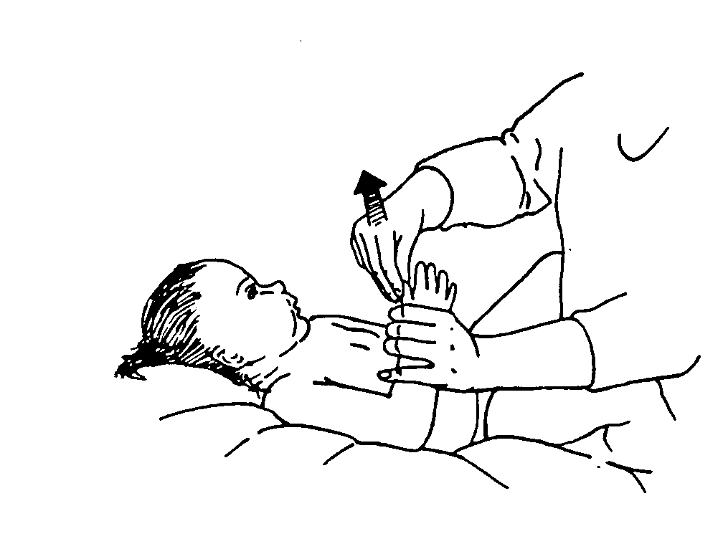
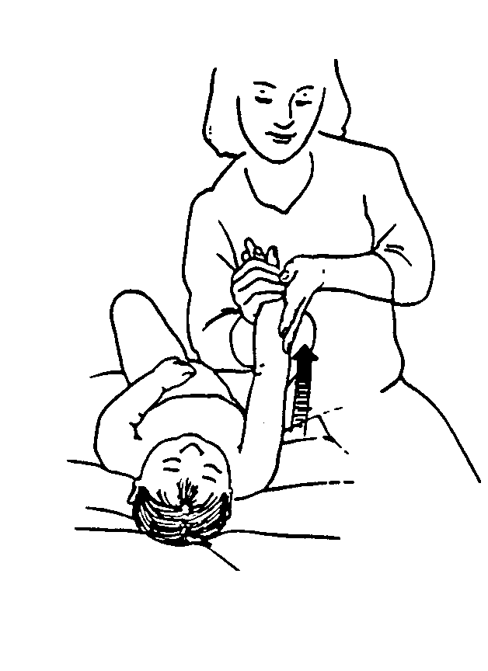 | 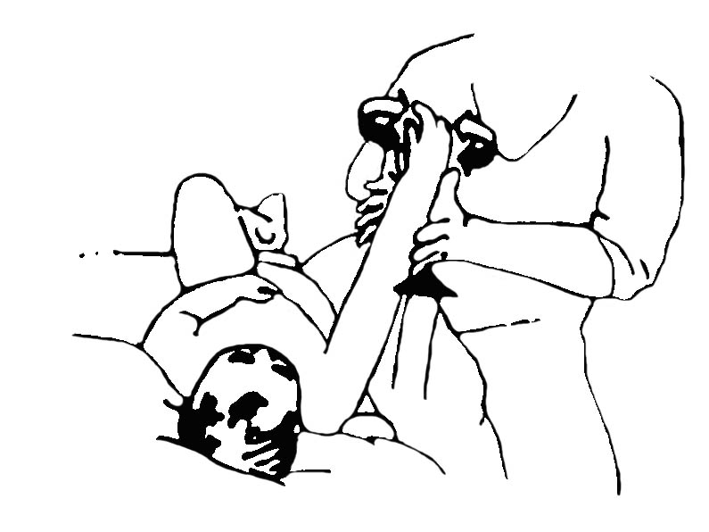 |  | 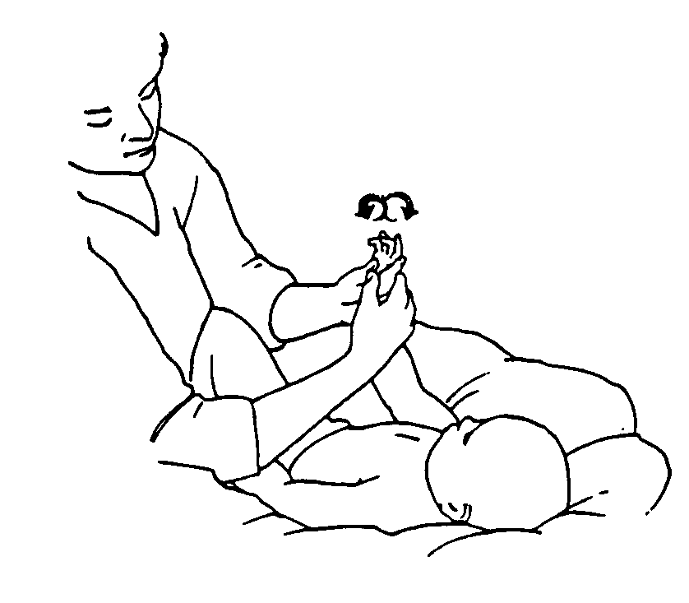
INFANT SIGN LANGUAGE
Teach your baby signs for playthings
ball | bear |  | blanket |  | book
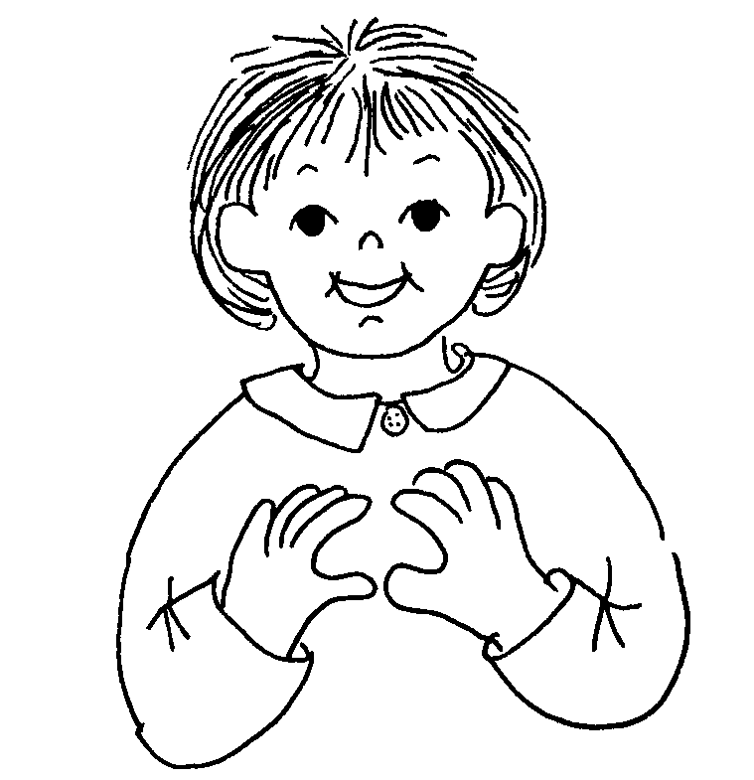 | 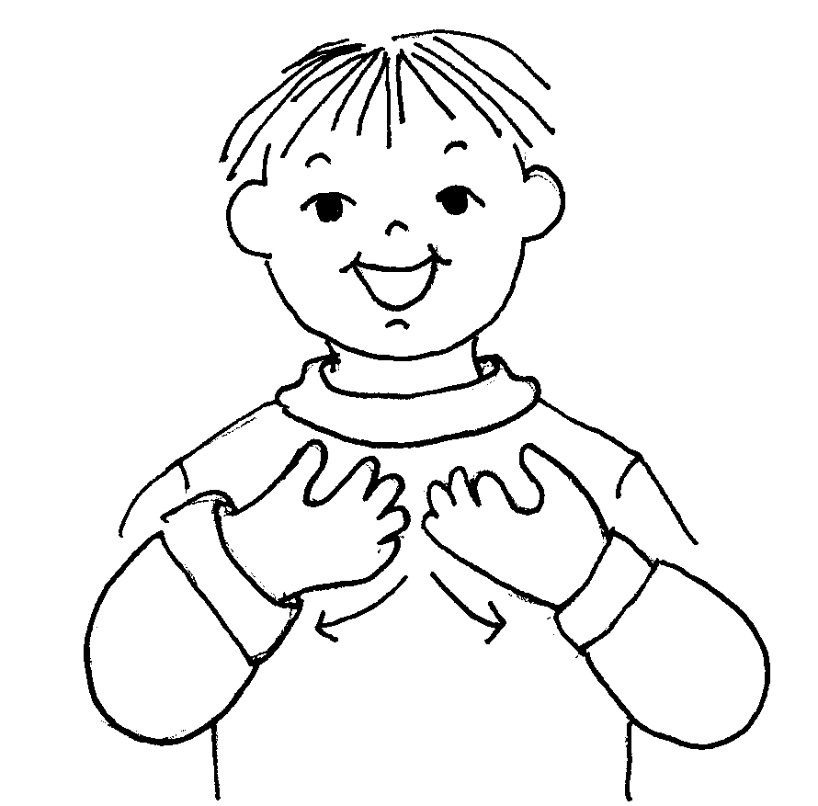 |  | 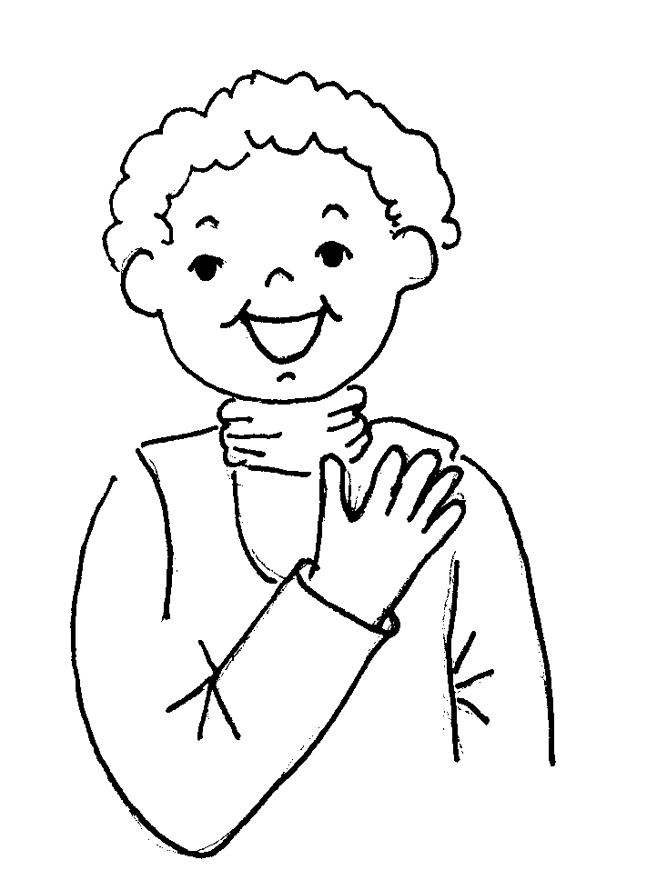 |  | 