BLOCKS AND CUPS
EXPLORATORY PLAY
Highlight sensory dimensions and follow your baby’s lead
look time | listening time | touching time |  | moving time
Light Toys   Looks at toy   Tracks moving toy   Looks after dropped toy   Finds hidden toy | Pianos   Alerts to sound or voice   Attends to sound or voice   Searches for sound or voice   Plays with sound making toy | Wood Toys   Feels toy   Reaches, mouths and shakes toy   Bangs, waves, and transfers toy   Points, pokes, and activates toy |  | Movement   Rolls back and forth   Gets in and out of sitting   Crawls to explore   Pulls to stand and walk
BABY GAMES
Gather and settle with baby board books, pat and turn pages, point to and talk about pictures.
hello time | wake up time |  | mealtime |  | bathtime
Who’s Here Today?  Lifting Game  Tune: “The Farmer On The Dell”  _______’s here today,  _______’s here today,  We’re so glad that ______’s here,  Let’s all shout, “Hurray!” “Hurray!”  How big is baby? Baby is so big. | Jack And Jill  Bouncing Game  Jack and Jill went up the hill  To fetch a pail of water.  Jack fell down and broke his crown  And Jill came tumbling after. |  | Pat-A-Cake  Clapping Game  Pat-a-cake, pat-a-cake, Baker’s man,  Bake me a cake, as fast as you can.  Roll it, pat it, and mark it with a “B,”  And put it in the oven, for Baby and me. |  | Round The Garden  Tickling Game  Round and round the garden,  Went the Teddy Bear.  One step, two steps,  Tickle under there.
Name and lift each Baby and ask, “What’s new?” | Bounce Baby to nursery rhyme. |  | Clap and gesture to rhyme. |  | Gesture to rhyme.
Leg Over Leg  Lifting Game  Leg over leg,  As the dog went to Dover.  He came to a fence,  And whoops!  He jumped over. | Bouncy, Bouncy  Bouncing Game  Bouncy, bouncy, we like to bouncy.  Bouncy, bouncy, one, two, three!  Bouncy, bouncy, we like to bouncy,  Bouncy, bouncy, bounce with me! |  | If You’re Happy  Clapping Game  If you’re happy and you know it,  Clap your hands.  If you’re happy and you know it,  Clap your hands.  If you’re happy and you know it,  Then your face will surely show it.  If you’re happy and you know it,  Clap your hands. |  | This Little Piggy  Tickling Game  This little piggy went to market.  This little piggy stayed home.  This little piggy had roast beef.  This little piggy had none.  This little piggy cried  Wee, wee, wee all the way home.
Move Baby’s legs and lift to game. | Bounce Baby on knee to rhyme. |  | Clap Baby’s hands to song. |  | Touch Baby’s fingers or toes to rhyme.

LEARNING FUN
Enjoy your baby, talk, play, cuddle and sing
talking time |  | playing time |  | cuddling time
Tell Me A Story   Talk about what you are doing   Talk about what Baby is doing   Ask Baby questions   Wait for Baby to talk back to you |  | Blocks And Cups   Explore blocks and cups using all senses   Bang two blocks together   Help baby put blocks in and out of cups   Play peek-a-boo games with blocks and cups |  | Twinkle Twinkle  Twinkle, twinkle little star,  How I wonder what you are?  Up above the world so high,  Like a diamond in the sky.  Twinkle, twinkle little star,  How I wonder what you are?
Talking to Baby teaches new words  and develops communication skills. |  | Exploring toys together encourages  Baby to develop thinking skills.
INFANT MASSAGE
Massage legs to orchestra background music
indian milking | wringing  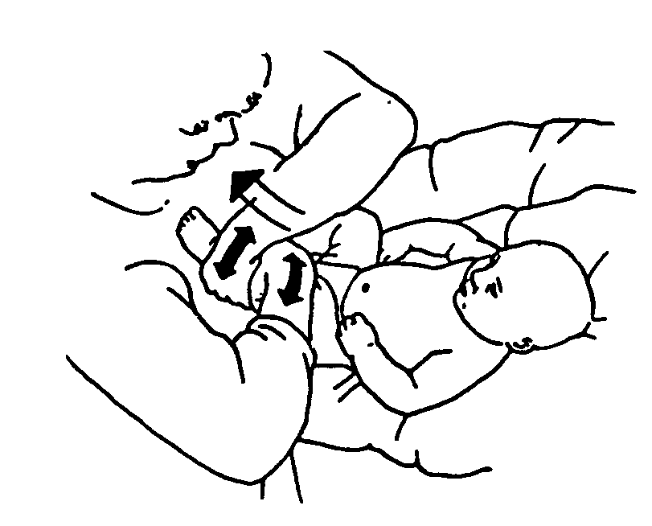 |  | swedish milking |  | rolling  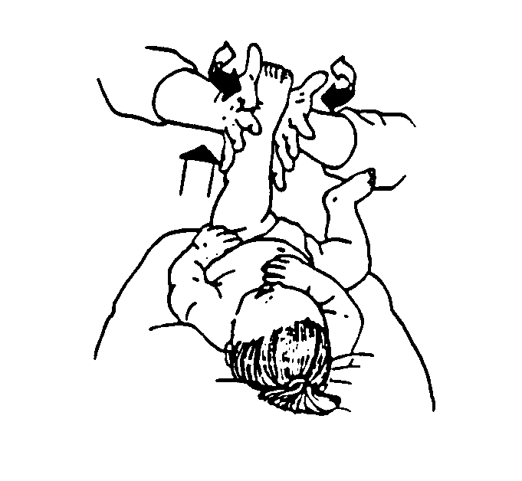
 |  |  | 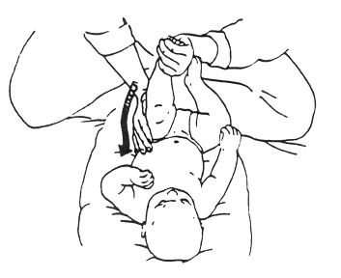
INFANT SIGN LANGUAGE
Teach your baby signs for requests
up  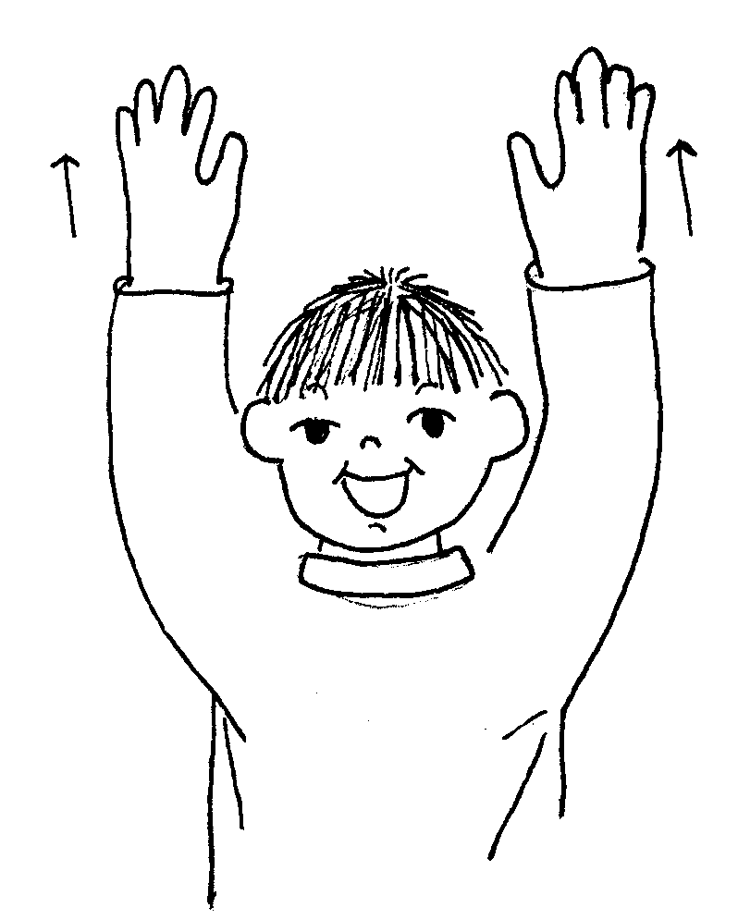 | 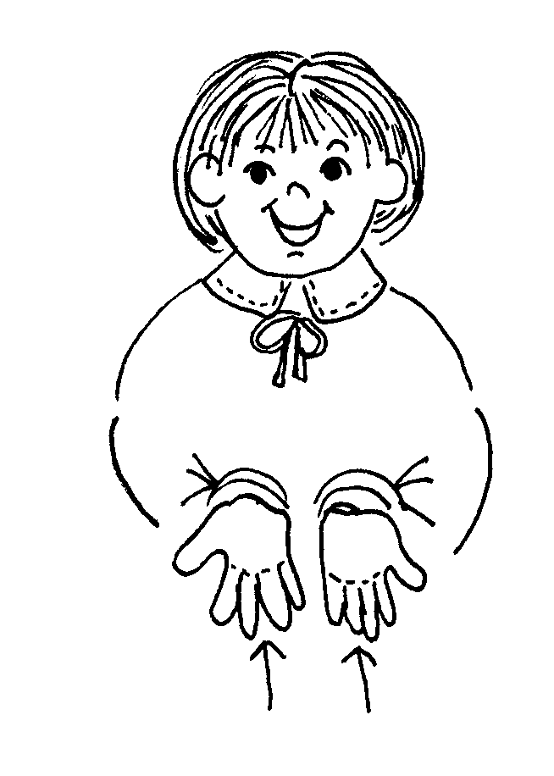  want |  | 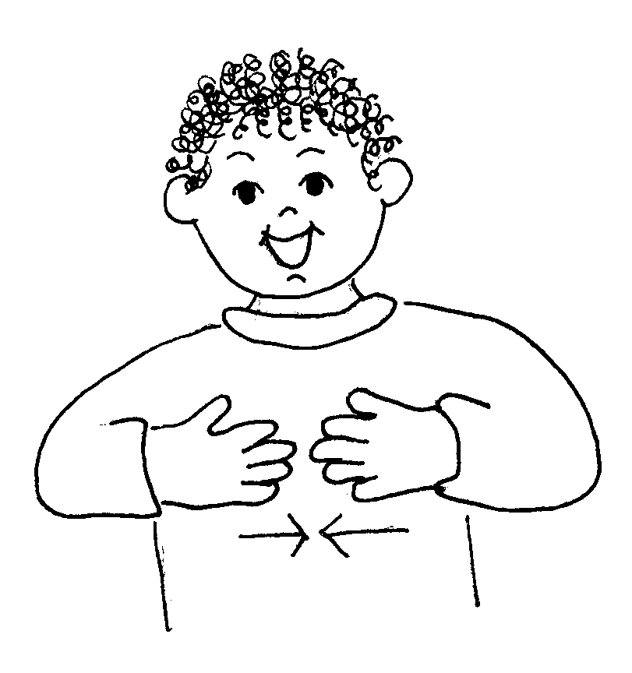  more |  | bye-bye
 |  |  |  |  | 