EXPLORATORY PLAY
Highlight sensory dimensions and follow your baby’s lead
looking time | listening time | touching time | moving time
Neon toys   Looks at toy   Tracks moving toy   Looks after dropped toy   Finds hidden toy | Clackers Time   Alerts to sound or voice   Attends to sound or voice   Searches for sound or voice   Plays with sound making toy | Metal Toys   Feels toy   Reaches, mouths and shakes toy   Bangs, waves, and transfers toy   Points, pokes, and activates toy | vestibular   Calms to rocking   Enjoys baby swing   Enjoys bouncing/lifting games   Enjoys riding toy
BABY GAMES
Gather and settle with baby board books, pat and turn pages, point to and talk about pictures
hello time | wake up time | mealtime | bathtime
Who’s Here today?  Lifting Game  Tune: “The More We Get Together”  Oh, here we are together, together  together  Oh here we are together at our school.  Here’s_____,and_____, and_____,  and _______, etc.  Oh, here we are together at our school.  How big is baby? Baby is so big! | Hickory Dickory Dock  Bouncing Game  Hickory Dickory Dock,  The mouse ran up the clock.  The clock struck one  The mouse ran down,  Hickory, Dickory dock. | Pat-A-Cake  Clapping Game  Pat-a-cake, pat-a-cake, Baker’s man,  Bake me a cake, as fast as you can.  Roll it, pat it, and mark it with a “B,”  And put it in the oven, for Baby and me. | Round The Garden  Tickling Game  Round and round the garden,  Went the Teddy Bear.  One step, two steps,  Tickle under there.
Name each Baby and ask what’s new. | Bounce Baby to nursery rhyme. | Clap and gesture to rhyme. | Gesture to rhyme.
Jack In The Box  Lifting Game  Jack in the box,  Sits so still.  Won’t you come out?  Yes I will! | On And On  Bouncing game  Father, mother, and uncle John,  Rode to the doctor one by one,  Father fell off, Mother fell off,  And Uncle John rode on and on,  And Uncle John rode on. | Make A Pancake  Clapping Game  Make a pancake, pat, pat, pat.  Do not make it fat, fat, fat.  You must make it flat, flat, flat.  Make a pancake just like that! | Criss Cross Applesauce  Tickling Game  Criss cross applesauce,  A cool breeze,  A tight squeeze,  And a tickle, tickle, tickle,  If you please.
Lift Baby to game. | Bounce Baby to rhyme. | Clap Baby’s hands to rhyme. | Gesture to rhyme.
BUSY TOYS
LEARNING FUN
Enjoy your baby, talk, play, cuddle and sing
talking time |  | playing time |  | cuddling time
Singing   Hum and sing to Baby   Dance and sing with Baby   Listen to music and sing with Baby   Play musical instruments together |  | Busy Toys   Explore cause and effect toy using all senses   Help baby anticipate action of cause and effect toy   Let baby control action or cause and effect toy   Play Peek-A-Boo game with cause and effect toy |  | Lullaby And Goodnight  Lullaby and goodnight,  Sleep is softly around you.  While your dreams fill your eyes,  With a melody of love.  Lay you down now to rest,  May your slumber be blessed.  Lay you down now to rest,  May your slumber be blessed.
Music uses all parts of Baby’s brain and  helps language and math skills develop. |  | Exploring at toys together encourages  Baby to develop thinking skills.
INFANT MASSAGE
Massage face to woodwind background music
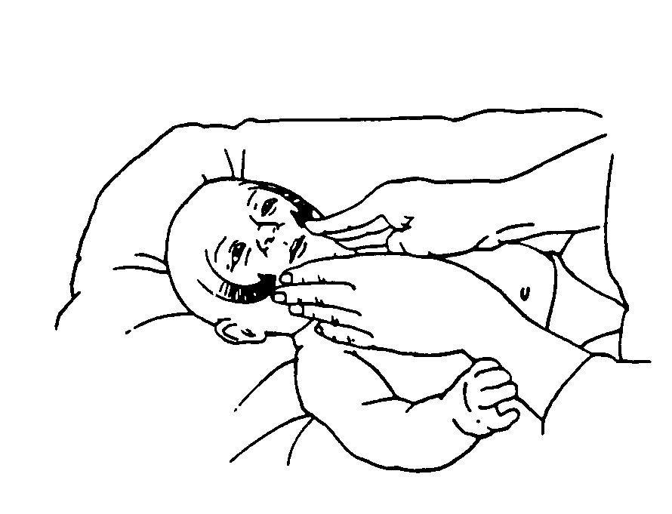  forehead to mouth | eyebrow to mouth |  | 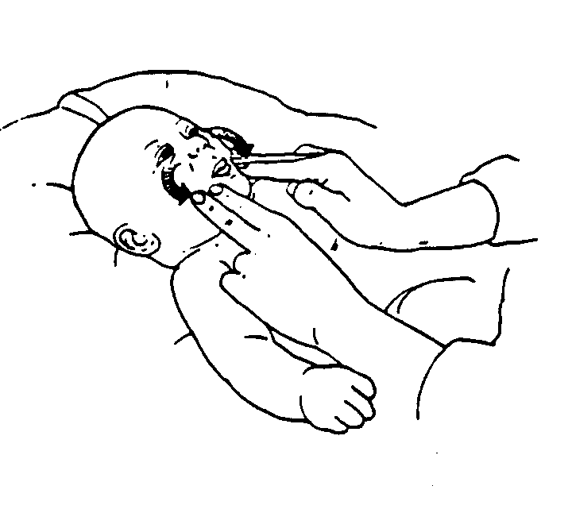  nose to mouth |  | 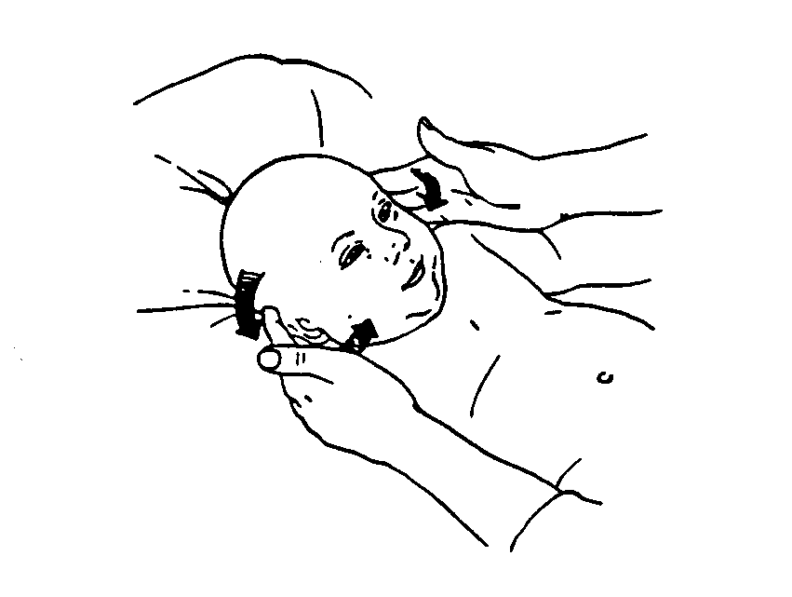  around the ears
 | 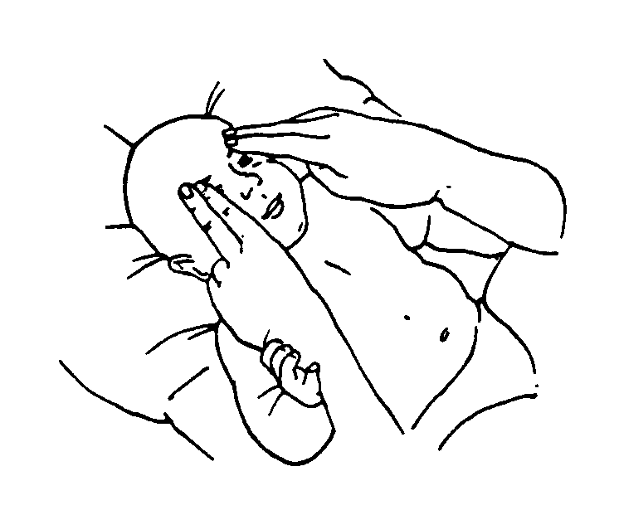
INFANT SIGN LANGUAGE
Teach your baby signs for eating
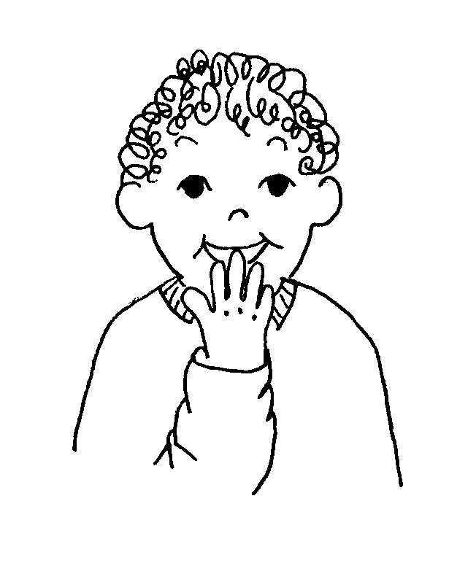  eat | 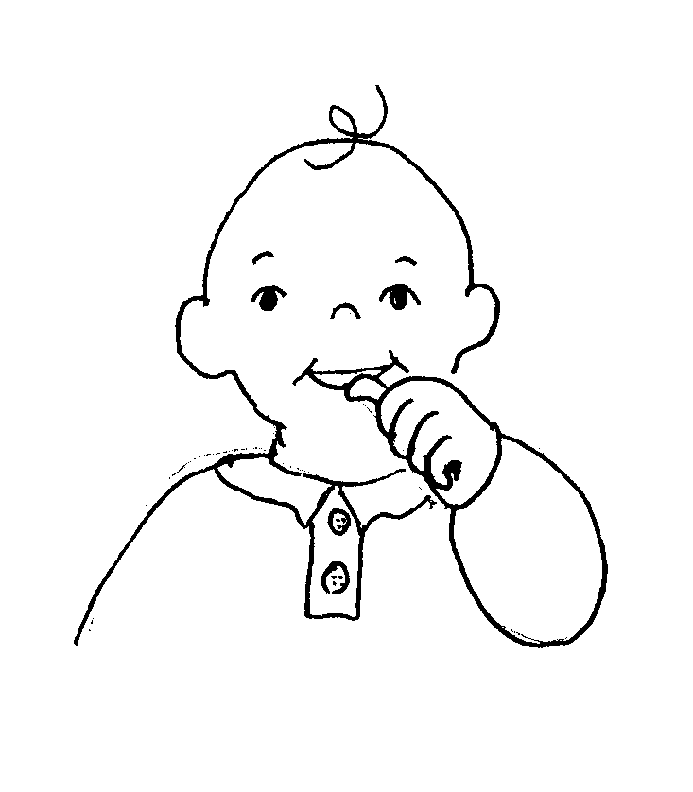  drink |  | 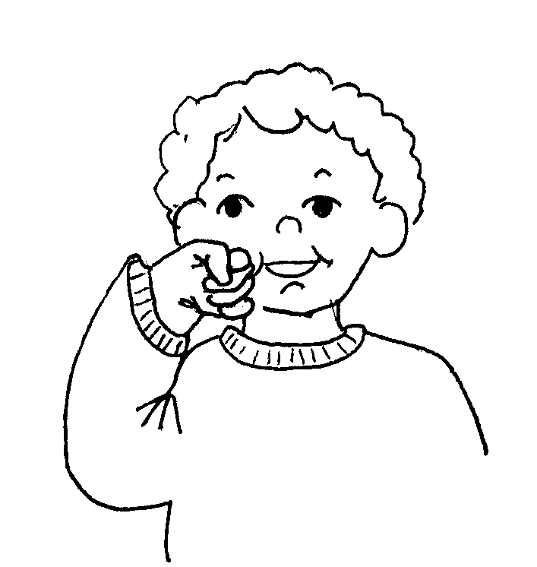  apple |  | 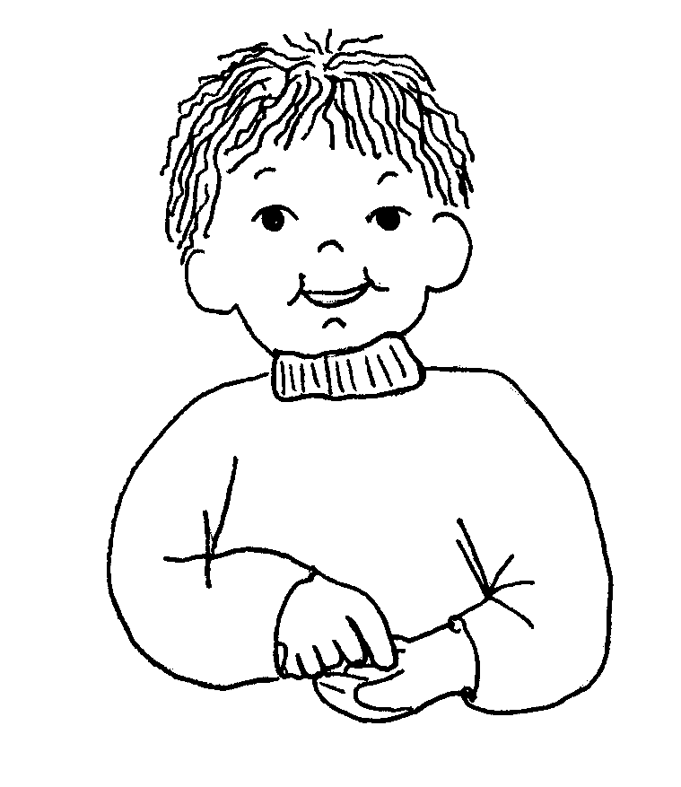  cookie

