EXPLORATORY PLAY
Highlight sensory dimensions and follow your baby’s lead
looking time | listening time | touching time | moving time
High Contrast Toys   Looks at toy   Track moving toy   Looks after dropped toy   Finds hidden toy | Bells   Alerts to sound or voice   Attends to sound or voice   Searches for sound or voice   Plays with sound making toy | Plastic Toys   Feels toy   Reaches, mouths and shakes toy   Bangs, waves, and transfers toy   Points, pokes, and activates toy | Balance   Lifts and rotates head   Shifts weight when tilted   Maintains balance sitting   Cruises or walks
BABY GAMES
Gather and settle with baby board books, pat and turn pages, point to and talk about pictures
hello time | wake up time | mealtime | bathtime
Who’s Here Today?  Lifting Game  Tune: “The Farmer in The Dell”  _______’s here today,  _______’s here today,  We’re so glad that ______’s here,  Let’s all shout, “Hurray!” “Hurray!”  How big is baby? Baby is so big! | Humpty Dumpty  Bouncing Game  Humpty Dumpty sat on the wall.  Humpty Dumpty had a great fall.  All the king’s horses and  All the king’s men,  Couldn’t put Humpty together again. | Pat-A-Cake  Clapping Game  Pat-a-cake, pat-a-cake, Baker’s man,  Bake me a cake, as fast as you can.  Roll it, pat it, and mark it with a “B,”  And put it in the oven, for Baby and me. | Round The Garden  Tickling Game  Round and round the garden,  Went the Teddy Bear.  One step, two steps,  Tickle under there.
Name and lift Baby and ask, “What’s new?” | Bounce Baby to nursery rhyme. | Clap and gesture to rhyme. | Gesture to rhyme.
The Monkey And The Weasel  Lifting Game | Little Red Wagon  Bouncing Game  Tune: “Oh My Darling Clemintine” | Pease Porridge Hot  Clapping Game | These Are Baby’s Fingers  Body Part Game
All around the cobbler’s bench,  The monkey chased the weasel.  The monkey thought ‘twas all in fun.  Pop! Goes the weasel. | Bumpin’ up and down  In my little red wagon.  Bumpin’ up and down  In my little red wagon.  Bumpin’ up and down  In my little red wagon.  Won’t you be my darling? | Pease porridge hot,  Pease porridge cold,  Pease porridge in the pot  Nine days old.  Some like it hot,  Some like it cold,  Some like it in the pot  Nine days old! | These are Baby’s fingers,  These are Baby’s toes,  This is Baby’s belly button,  Round and round it goes.
Lift Baby on “Pop!” | Bounce Baby to song. | Clap Baby’s hands to rhyme. | Touch Baby’s body parts, to rhyme.
SQUEAK TOYS AND RATTLES
LEARNING FUN
Enjoy your baby, talk, play cuddle and sing
talking time |  | playing time |  | cuddling time
Face to Face Interactions   Make silly sounds to Baby   Imitate Baby’s sounds   Take turns”talking” back and forth   Touch and name the parts of Baby’s face |  | Squeak Toys And Rattles   Explore squeak toys using all senses   Help baby anticipate actions of squeak toys and rattles   Let baby control actions of squeak toys and rattles   Play Peek-A-Boo games with squeak toys and rattles |  | Rock A Bye Baby  Rock-a-bye Baby,  On the tree top,  When the wind blows,  The cradle will rock.  When the bough breaks,  The cradle will fall.  And down will come Baby,  Cradle and all.
Face to face interactions build attention  and teach communications skills. |  | Exploring toys together encourages  Baby to develop thinking skills.
INFANT MASSAGE
Massage stomach and back to piano background music
paddle wheel | thumbs to side |  | back and forth  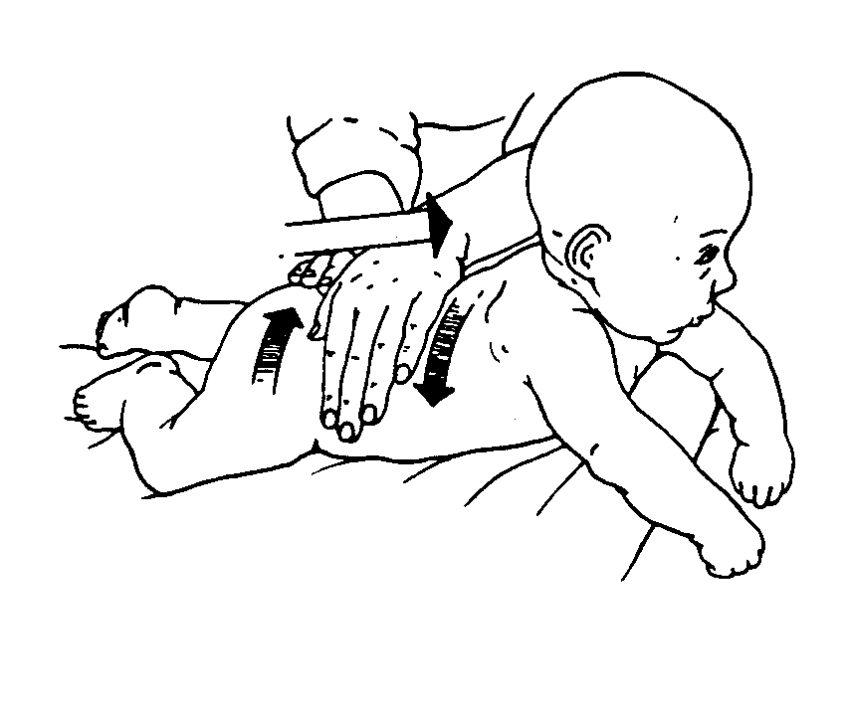 | small circles over back
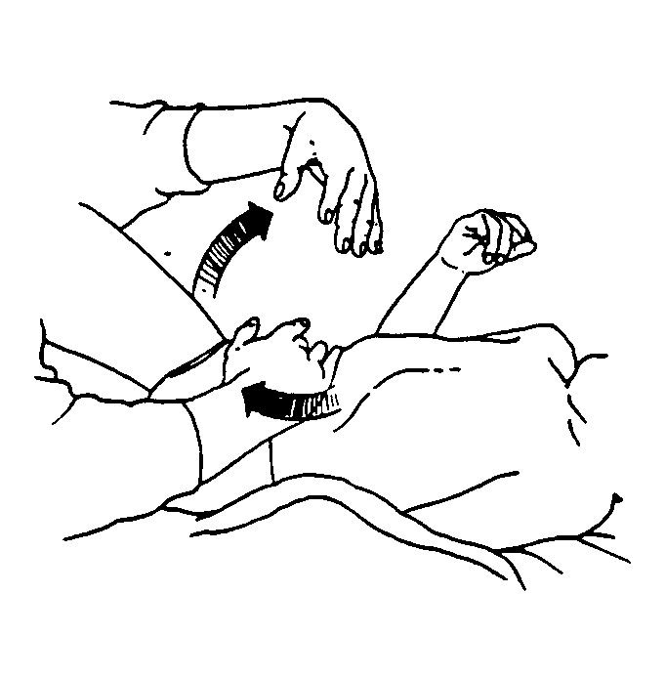 | 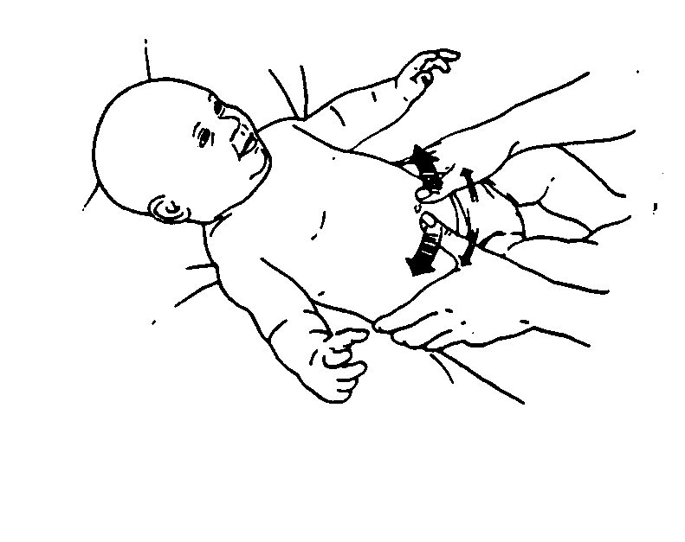 |  |  | 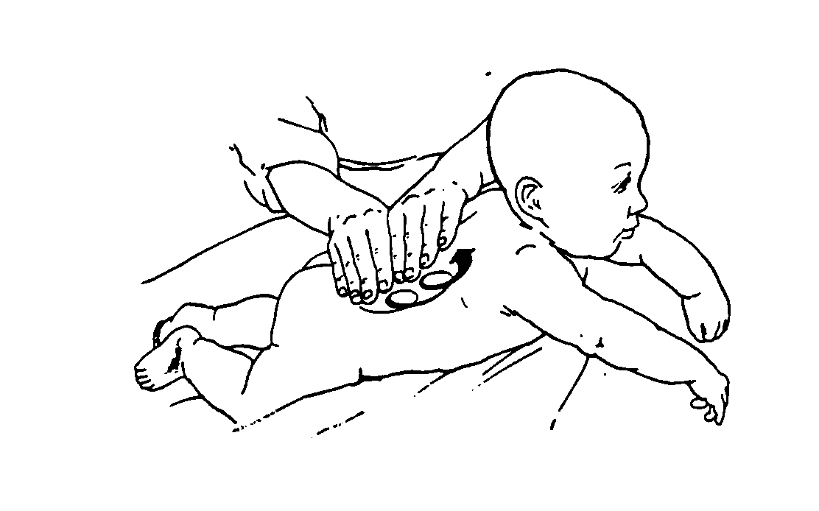
INFANT SIGN LANGUAGE
Teach your baby signs for people
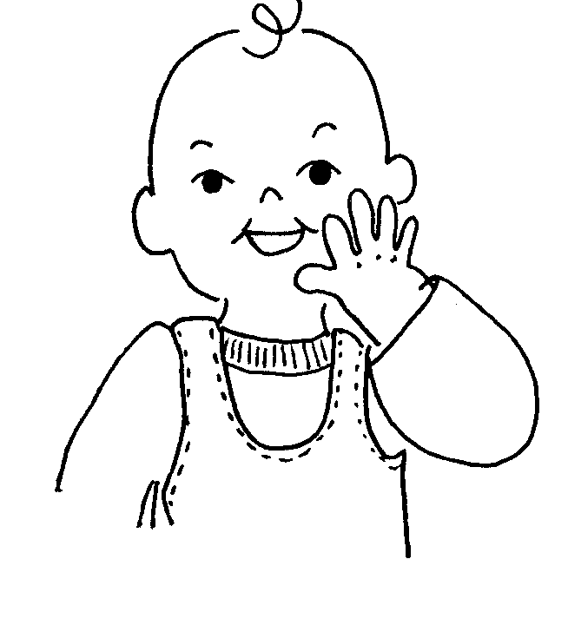  mommy | daddy  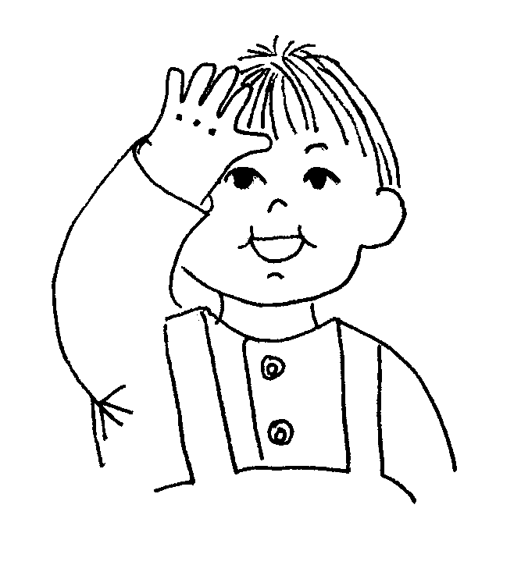 |  | 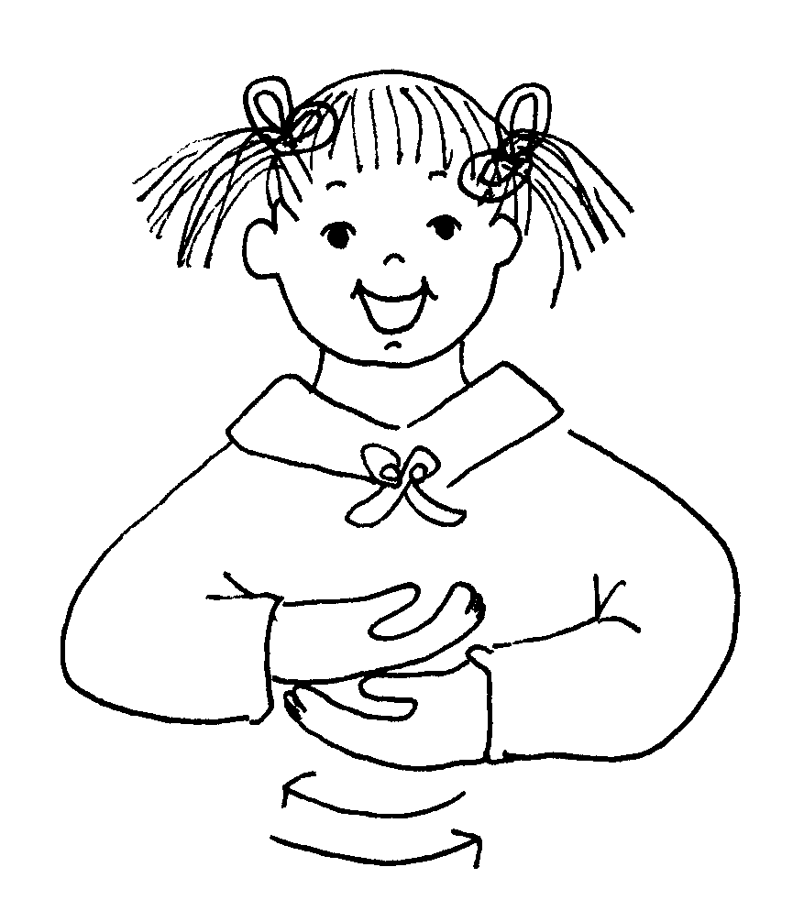  baby | 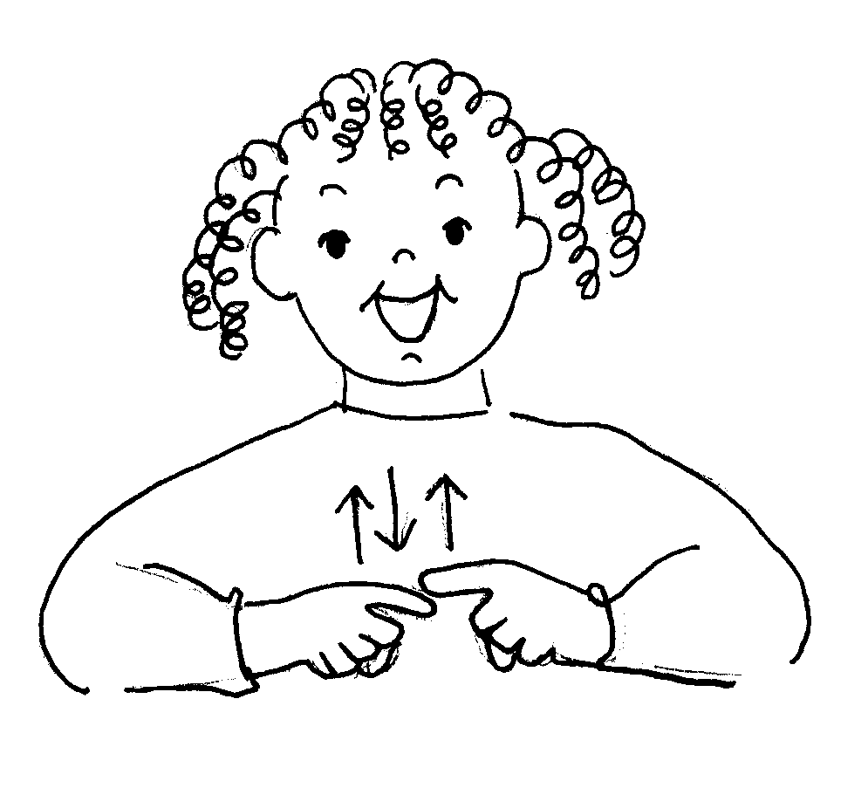  friend

