SQUEAK TOYS AND RATTLES
BABY MASSAGE LEGS

Indian Milking | Wringing
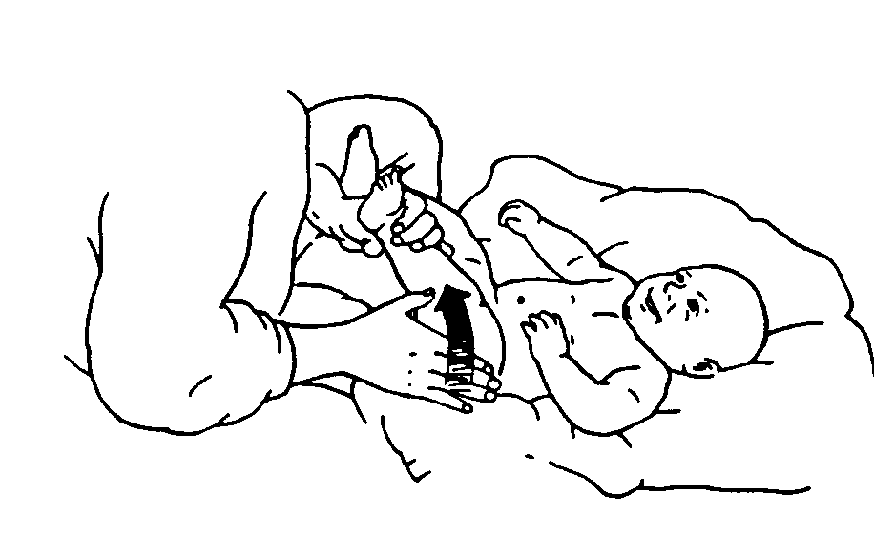  - Support the leg at the inside ankle with one hand.  Stroke the leg from the outer border of the thigh to  the ankle with your other hand.  - Alternate hands. Stroke from the inner thigh to the ankle.  - Continue to alternate inside and outside strokes moving from the hip to the ankle. | 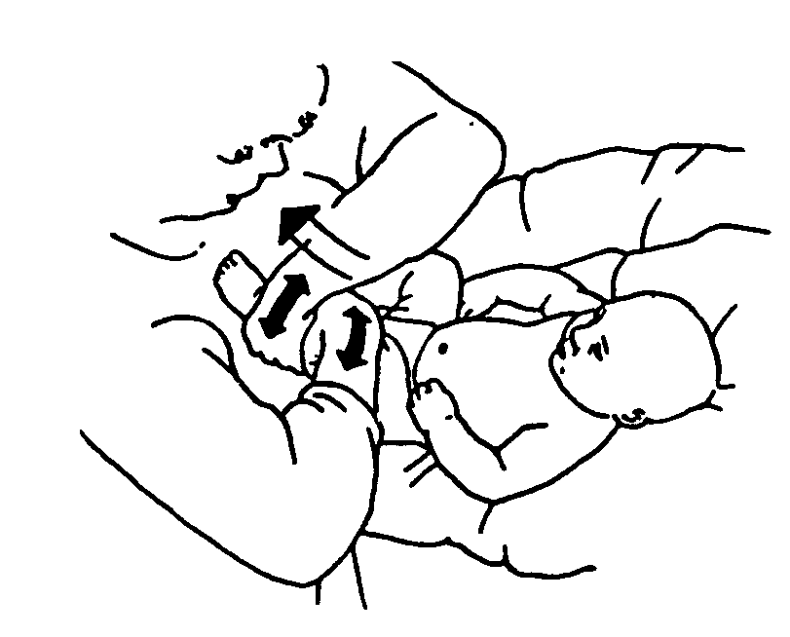  - Wrap your hands around the leg at the thigh.  - Gently wring the leg in both directions by twisting your hands together and then apart. Simultaneously, glide your hands toward the ankle.  - When your hands reach the wrist, pause a moment to allow Baby to accommodate the input before repeating the stroke.  - As your hands come to the ankle, first bring one hand back to the hip, and then follow with the other. This assures consistent tactile contact.
Swedish Milking | Rolling
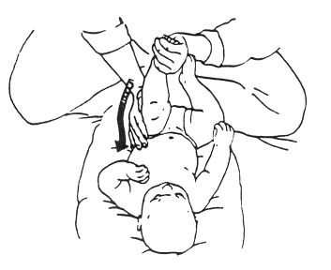  - Support the leg with one hand at inside ankle. Use the other hand to stroke firmly from the ankle to the hip on the outside surface of the leg.  - Stroke around the hip without breaking contact. Stroke back toward the ankle using your finger pads and a lighter pressure.  - Switch hands by supporting leg at outside ankle. Use your hands to stroke firmly from the inner ankle to the inner thigh.  - Stroke back toward the ankle, using your finger pads  and a lighter pressure. | 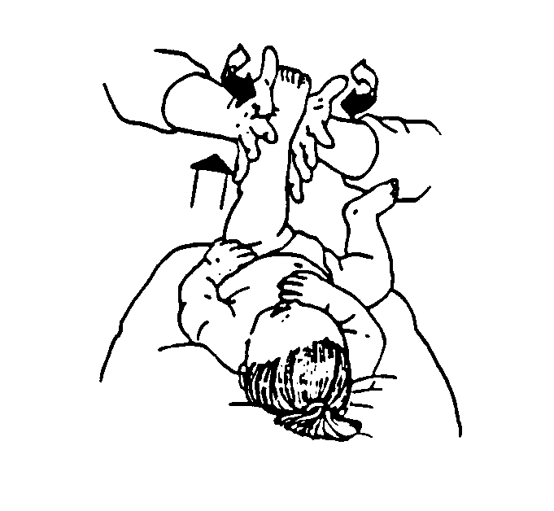  - Place the flat part of your palms on the inner and outer surfaces of the upper thigh.  - Gently alternate your hands to produce a rolling motion, like rolling dough. Simultaneously glide your hands toward the foot while rolling.  - Maintain one hand at the ankle and reposition the other hand to the hip ensuring continual contact.

