BLOCKS AND CUPS
BABY MASSAGE ARMS AND HANDS

Swedish Milking | Rolling
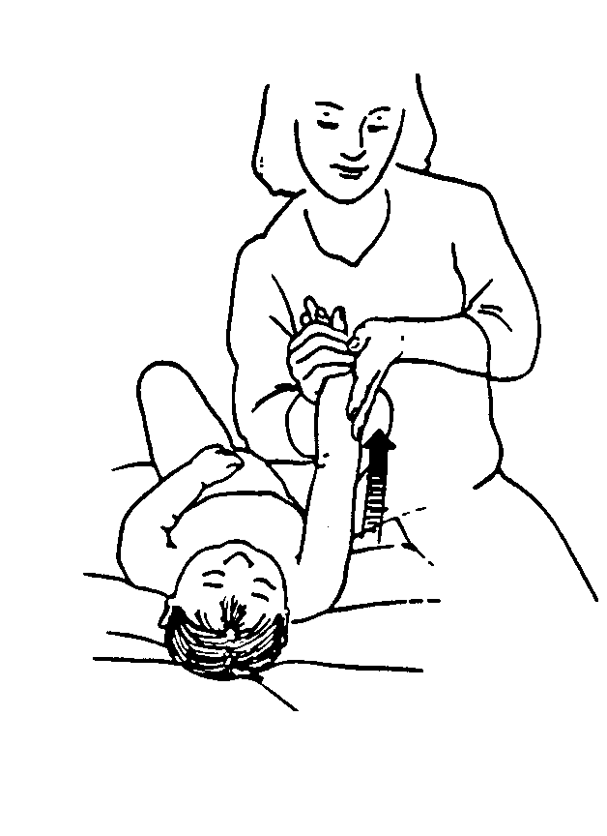  - Support the arms with one hand at the inside wrist. Use your other hand to stroke firmly from the wrist to the shoulder on the outside surface of the arm.  - Stroke around the shoulder, without breaking contact. Stroke back toward the wrist, using your fingerpads and a lighter pressure.  - Switch hands by supporting the arm at the outside wrist. Use the palm of other the hand to stroke firmly from the inside wrist to the shoulder girdle.  - Stroke back toward the wrist using your fingerpads and lighter pressure. Repeat. Continue alternating hands. | 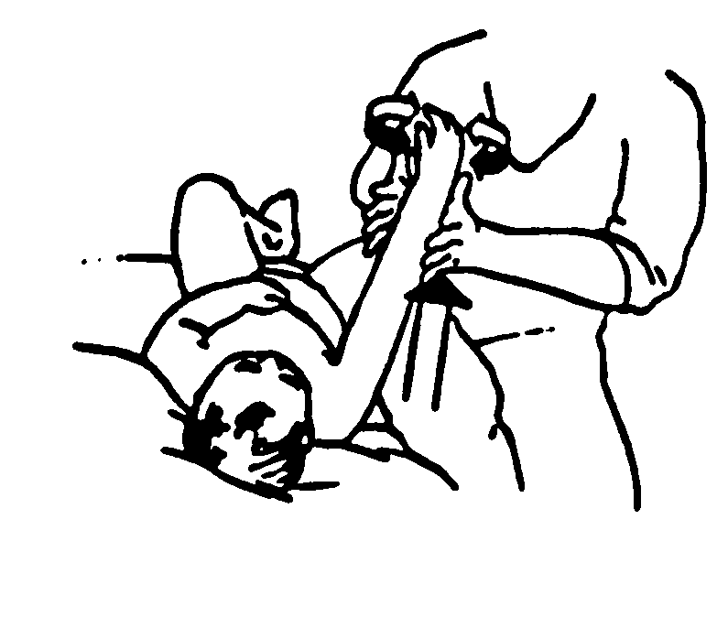  - Cup your hands around the child’s upper arm.  - Gently alternate your hands so as to produce a rolling motion, like rolling dough.  - When your hands reach the wrist, pause a moment to allow Baby to accommodate to the input before repeating the stroke.  - To ensure continued contact, maintain one hand at the wrist while moving the other hand to the upper arm.
Small Circles In The Palm | Squeeze Each Finger
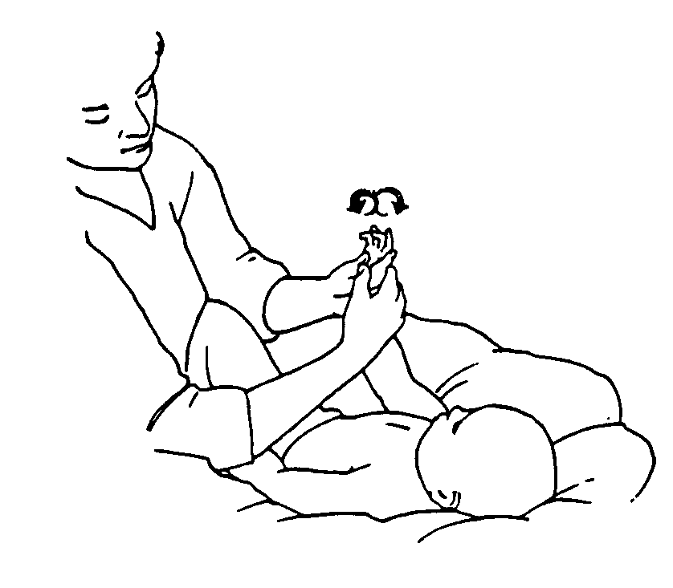  - Using your thumbs to make circles in the palm of the hand.  - Move your thumbs to a new location in the palm and make circles. | 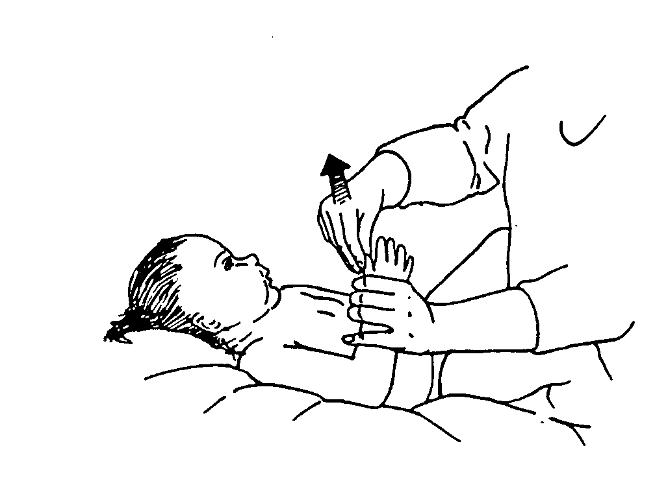  - Gently grasp the base of the thumbs on the top and bottom surface between your thumb and index finger.  - Slide your fingers from the base to the tip of the thumb. Use a gentle, rolling, squeezing motion.  - Repeat with each finger in order.

