BUSY TOYS
BABY MASSAGE STOMACH AND BACK

Paddlewheel | Thumbs To Side
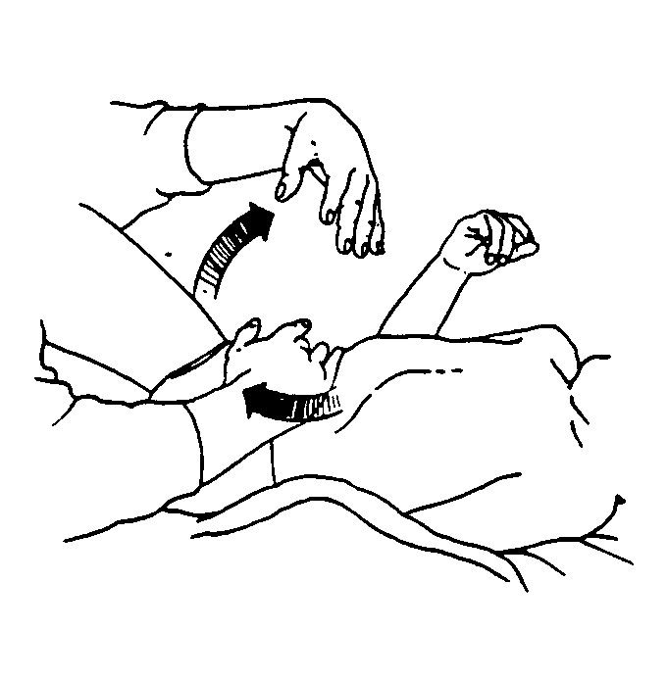  - Place one hand in the center of Baby’s abdomen, below the rib cage.  - Glide hand down toward the groin area.  - Repeat with the other hand, making a paddling motion.  - Continue alternating hands. Make sure that one hand is always in contact with the stomach. | 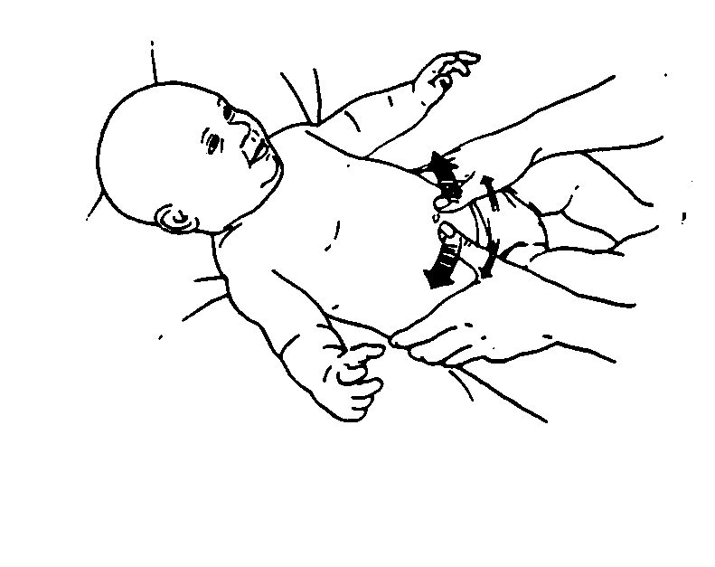  - Place a thumb on each side of the navel.  - Move thumbs outward at the navel.  - Repeat, beginning from a slightly lower position each time, until you have reached the groin area.
Back And Forth | Small Circles All Over The Back
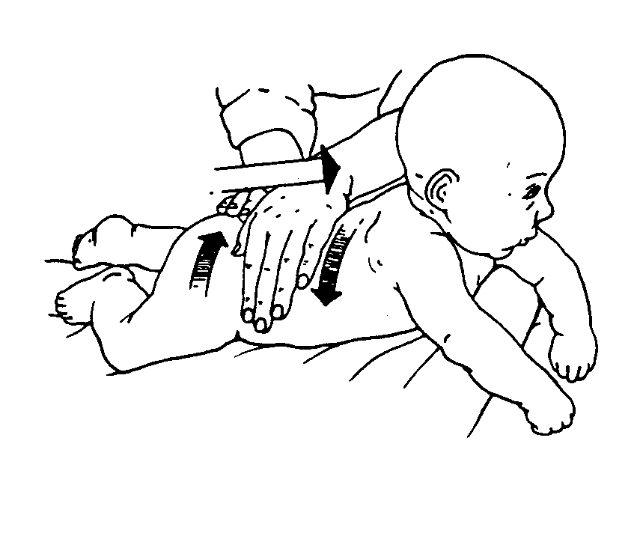  - Place your relaxed hands on the buttocks.  - Alternate your hands back and forth, gliding over the entire back surface from the buttocks to the neck.  - Move one hand back down to the buttocks, while the other maintains contact at the neck.  - Return the other hand to the buttocks and repeat. | 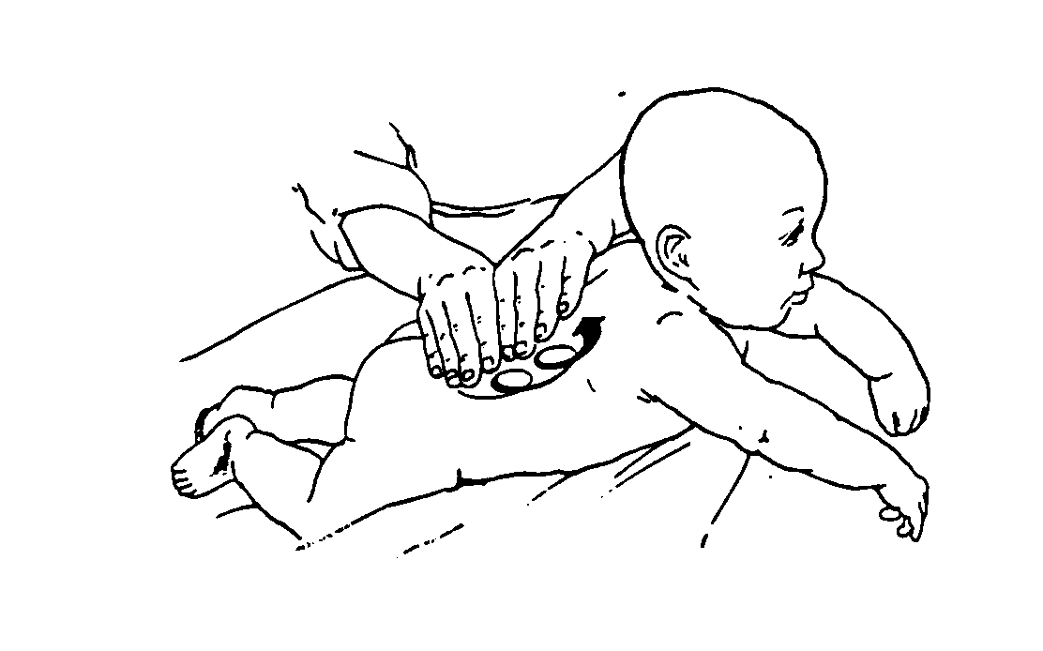  - Place fingerpads together on one side of the base of the spine.  - Moving hands in unison, make clockwise circles that move up to the top of the spine.  - Cross over to the other size, avoiding pressure on the spine. Continue the circular motion down to the bottom of the spine.  - Cross again to the other side and repeat.

