STUFFED ANIMALS
BABY MASSAGE FACE

Forehead To Mouth | Eyebrow To Mouth
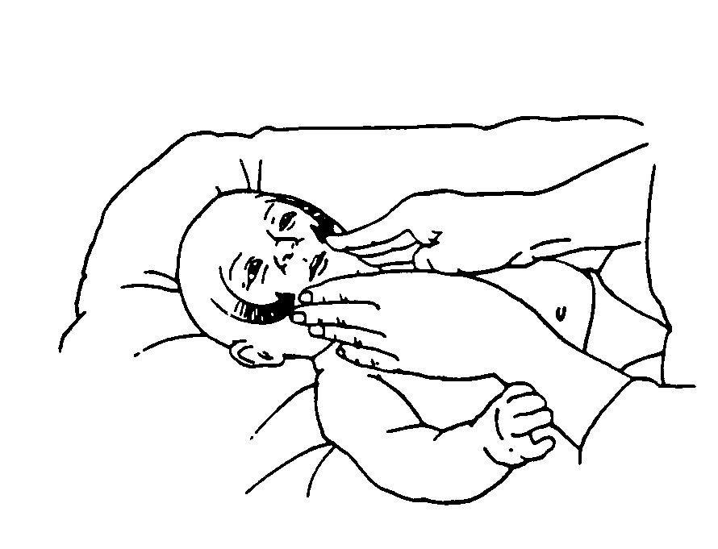  - Place fingerpads of both hands at the middle of Baby’s forehead.  - Move hands out and downward over the cheeks, bringing them back together near the mouth. | 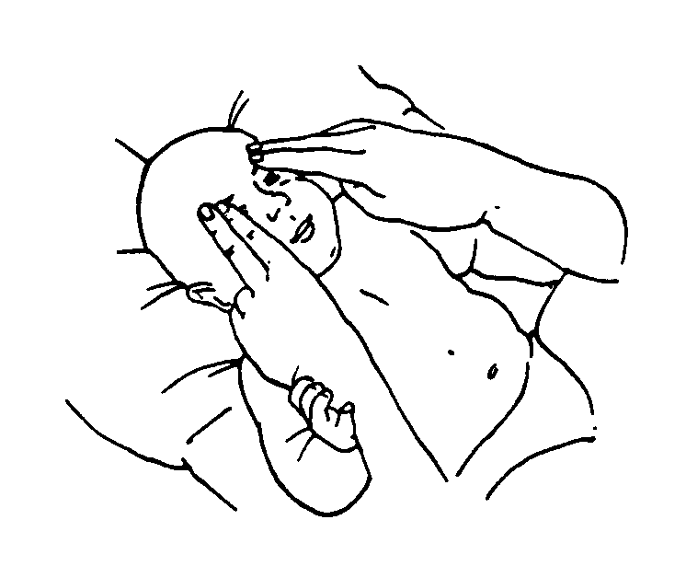  - Place fingerpads of both hands at midline, eyebrow-level.  - Move hands out and downward over the cheeks, bringing them back together near the mouth.
Nose To Mouth | Small Circles All Over  The Back Of The Ears
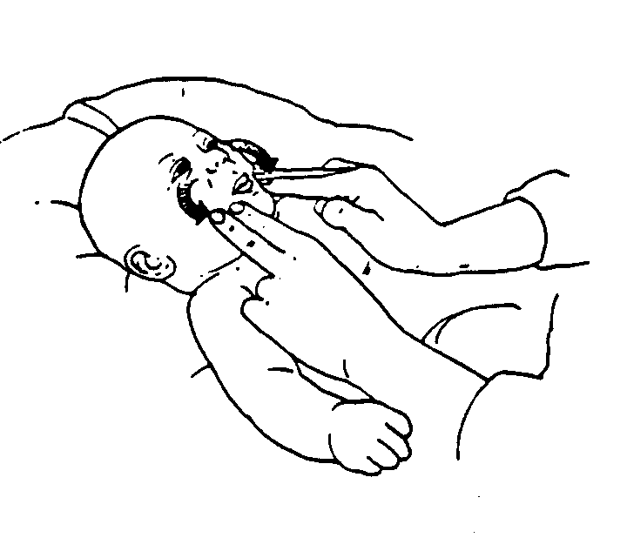  - Place fingerpads on both sides of the nose.  - Move hands out and downward over the cheeks, bringing them back together near the mouth.  - Repeat the series. | 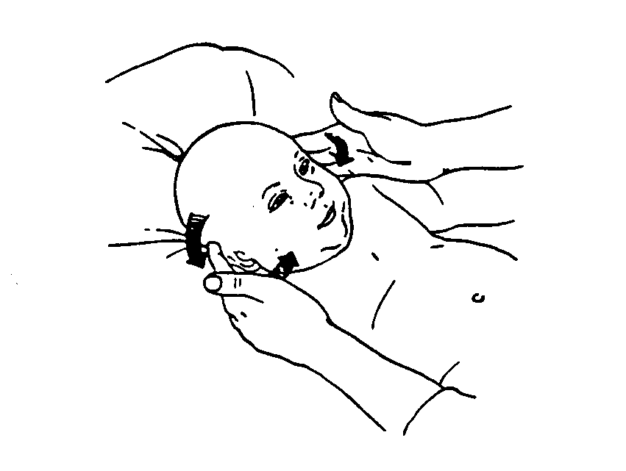  - Place fingerpads on the temples, just above the tops of the ears.  - Move hands over and behind ears. Continue across the cheeks to the mouth.  - Repeat the series. Try to maintain contact with the Baby’s face and head throughout.

