SCRIBBLE PACK

OUTDOORS

“A scribble a day brings a writer your way.”

Sunday | Monday | Tuesday | Wednesday | Thursday | Friday | Saturday
 |  |  |  |  | 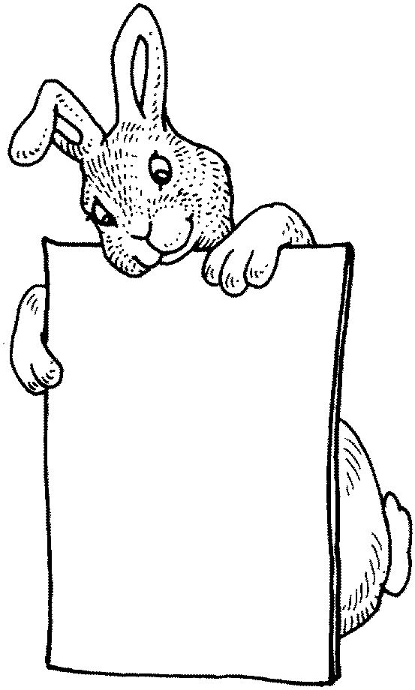
Sunday Scribble with your child. Follow directions…
Put together a toy, following the directions with your child.
Have fun ☺
Monday Scribble with your child. Write a letter…
Pick out a holiday greeting card. Let your child “address” the back
of the envelop. Put the card in the mailbox together.
Have fun ☺
Tuesday Scribble with your child. Look up something…
Find an ad in the Penny Saver with your child. Circle the ad,
call for information, then go pick up your treasure together.
Have fun ☺
Wednesday Scribble with your child. Draw a picture…
Encourage your child to scribble on the bunny pictures. Draw
a picture of a bunny together on a blank sheet of paper.
Have fun ☺
Thursday Scribble with your child. Leave a note…
Think of something you and your child want to remember to do
when you go out. Write it on a post-it note and put it on the door.
Have fun ☺
Friday Scribble with your child. Make a sign…
Find something you want to sell. Make a for-sale sign
with your child. Put the item in a garage sale.
Have fun ☺
Saturday Scribble with your child. Make a list…
Make a grocery list with your child. Take the list to the store
and check off the things you find together.
Have fun ☺

