STORIES FOR TWOS

A Book a Day Brings a Reader Your Way

Max’s Ride, By Rosemary Wells

Sunday | Monday | Tuesday | Wednesday | Thursday | Friday | Saturday
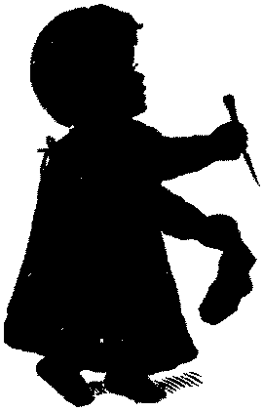 |  |  | Once  upon  a  time
Sunday Share a book with your child. Make it real…
Relate objects on the pages to real objects at home.

Have fun ☺
Monday Share a book with your child. Allow repetition…
Read the story with inflection to match the word written in bold.
repeat the emphasized words.
Have fun ☺
Tuesday Share a book with your child. Tell a picture story…
Look at Max and Ruby’s facial expressions on each page. Talk about
what Max and Ruby are feeling. Are they happy, sad, or afraid.
Have fun ☺
Once  upon  a  time | Wednesday Share a book with your child. Read the words…  Move your finger on each page as you follow along with the words. Use  your finger movements on the pages to show the meanings of the words.  Have fun ☺
Thursday Share a book with your child. Ask questions…
Ask your child what Max and Ruby are doing on each page.

Have fun ☺
Friday Share a book with your baby. Share with another…
Encourage your child to pretend to read the book to brother or sister.

Have fun ☺
Saturday Share a book with your baby. Visit the library…
Find other books by the author of this book, Rosemary Wells.

Have fun ☺

Website: www.fepecho.com

